Academy for Character and Excellence

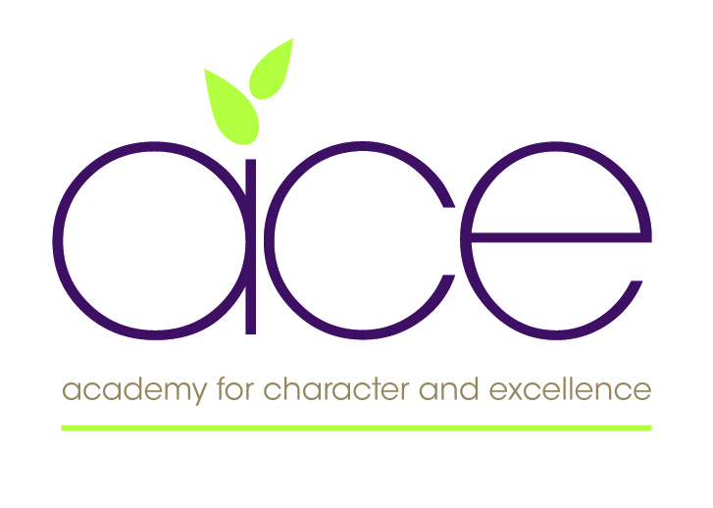

Relationships, Health and Sex Education Policy (RHSE)
Reference: WP/Curriculum and Standards/Ethos and Distinctiveness

Policy date | September 2020 | Statutory Policy - Yes
Board Approval | June 2023
Next Review Date | July 2024 | Review cycle every 2 years
Author | TP/WP/C&S/E&D | www.acexcellence.co.uk
MAT Schools | Redhills Primary  Shaldon Primary  Collaton St Mary  Galmpton Primary | Totnes St John’s  Brixham Primary  Torre C of E Academy

Contents

1. Aims 2
2. Statutory requirements 2
3. Policy development 2
Our approach and Rationale – Church Schools Only 3
Our approach and Rationale – Non Church Schools Only 3
4. The context for Sex and Relationships Education within the PSHE curriculum 4
Organisation and planning 4
5. Legal aspects relating to RHSE and cross referencing to other Policies 5
6. Creating a safe environment for teaching and learning 5
7. Confidentiality 6
8. Working with parents or carers 6
9. Monitoring and Evaluation 6
Appendix 1: What Pupils Should Know by the end of Primary School 7
Appendix 2: Introduction to the Christopher Winter Resources 9
Appendix 3: Tips for Teaching SRE with Confidence 10
Appendix 4: Christopher Winter Curriculum Overview 11

Appendix 5: A Charter for faith sensitive and inclusive relationships education, relationships and sex education (RSE) and Health Education (RSHE) ………………………………………………………………12

Appendix 5: Parent withdrawal form from sex education within RSE 14

1. Aims
This policy will apply to all parents and carers within all of our Schools with the Academy for Character and Excellence in relation to the Relationships, Health and Sex Education curriculum.
This policy will be reviewed every two years unless significant curriculum changes occur before the review date.
The aims of relationships and sex education (RHSE) at the schools within our Trust are to:
- Provide a framework in which sensitive discussions can take place
- Prepare pupils for puberty, and give them an understanding of sexual development and the importance of health and hygiene
- Help pupils develop feelings of self-respect, confidence and empathy
- Create a positive culture around issues of sexuality and relationships
- Teach pupils the correct vocabulary to describe themselves and their bodies

2. Statutory requirements
As a primary school within a Multi Academy Trust we must provide relationships education to all pupils as per section 34 of the Children and Social work act 2017.
We do not have to follow the National Curriculum but we are expected to offer all pupils a curriculum that is similar to the National Curriculum including requirements to teach science which would include the elements of sex education contained in the science curriculum.
In teaching RSE, we are required by our funding agreements to have regard to guidance issued by the secretary of state as outlined in section 403 of the Education Act 1996.
At Torre C of E Academy we teach RHSE as set out in this policy.

3. Policy development
This policy has been developed in consultation with staff, pupils and parents and involved the the following steps:
- Review – a member of staff or working group pulled together all relevant information including relevant national and local guidance

- Staff consultation – all school staff were given the opportunity to look at the policy and make recommendations

- Parent/stakeholder consultation – parents and any interested parties were invited to attend a meeting about the policy

- Pupil consultation – we investigated what exactly pupils want from their RHSE

- Once amendments were made, the policy was shared with governors for comments

- The Trust directors holding the Ethos and Distinctiveness and Curriculum and Standards portfolios were consulted with and ratified this policy before submitting to the board of directors.

- Approval – The board of directors approve the policy once these steps have been completed.

Our approach and Rationale – Church Schools Only

Our school’s approach to RSHE follows that of the Church of England Education Office in that it seeks to be faith-sensitive and inclusive. It is underpinned by two key Biblical passages:
“So God created humankind in his image, in the image of God he created them” (Genesis 2:7)
“I have come in order that you might have life - life in all its fullness” (John 10:10)
The Church of England’s Pastoral Advisory Group has set out some principles for living well together, accommodating difference and diversity within churches, especially in relation to LGBTI+ people, which provide helpful context and principles for schools. Church of England schools should ensure that their RSHE curriculum protects, informs and nurtures all pupils. It should clearly differentiate between factual teaching (biology, medicine, the law, marriage, different types of families and the composition of society) and moral teaching about relationships and values, recognising that the distinction can be easily blurred and there needs to be discernment about the manner in which this is taught within a moral (but not moralistic) framework.

In Torre Church of England School, everyone will be treated with dignity as all people are made in the image of God and are loved equally by God.
All pupils have a right to an education which enables them to flourish and is set in a learning community where differences of lifestyle and opinion (within that which is permissible under UK law) are treated with dignity and respect; where bullying of all kinds is eliminated; and where they are free to be themselves and fulfil their potential without fear.
Our school seeks to ensure that the RSHE curriculum protects, informs and nurtures all pupils. It clearly differentiates between factual teaching (biology, medicine, the law, marriage, different types of families and the composition of society) and moral teaching about relationships and values, recognising that the distinction can be easily blurred and that there needs to be discernment about the manner in which this is taught. We teach RSHE within a moral (but not moralistic) framework.
RSHE at Torre is about what constitutes wellbeing and loving care for ourselves (Physical and Mental Health Education), how we show loving care for others (Relationships Education) and, when at an appropriate age and stage in life, how we show loving care to those we choose to be intimate with, including within marriage (Sex Education).
It is also about the spiritual and moral aspects of healthy, loving and nurturing relationships within a context of a Christian vision for the purpose of life.
Pupils will consider how to ensure that they treat themselves and others, at all times and in all contexts, with dignity and respect.

This policy has been developed in accordance with –
- DfE:- RHSE guidance 2000 (Ref: DfEE 0116/2000)
- The Church Of England’s Guidance to Schools https://www.churchofengland.org/more/education-and-schools/church-schools-and-academies/relationships-sex-and-health-education
- Brook/PSHE Association/Sex Ed Forum document:-Sex and Relationships Education (RHSE) for the 21st Century, March 2014 (supplementary advice)
- KCSIE-Safeguarding guidelines for schools 2020

This policy has been updated in accordance with the above documents. A new RHSE scheme of work for Reception to Y6 has been purchased and is included in the PSHE overall scheme of work. The scheme (CWP Teaching RHSE with Confidence in Primary Schools) is highly recommended by the PSHE association and has been used successfully in many primary schools. This policy will be reviewed every two years or as needed to reflect any changes in legislation.

4. The context for Relationships, Health and Education within the PSHE curriculum
Our school aims and values underpin the ways in which we ensure a whole school approach to provide an effective taught curriculum for all our pupils and a sensitive response to pastoral issues. We believe that pupils have an entitlement to learn about sex and relationships as part of the wider PSHE provision. We acknowledge the vital role of parents and seek to support them through on-going consultation and ensuring that the policy reflects their views. We aim to meet the needs of all our pupils and respond to the range of cultures and sexual diversity.

Organisation and planning
Class teachers will deliver the sessions as set out in CWP ‘Teaching RHSE with Confidence in the Primary School.’ A staff meeting has been held to explore the sessions and to guide teachers to the relevant resources for the lessons. Our Ethos Committees have also contributed to this policy and considered very carefully our response to the teaching of RHSE.

As in all areas of the curriculum, teachers will use a variety of teaching and learning methods and approaches including discussion, project learning, DVD, circle time, group work, drama and role play.

Teachers should follow the plans for their year group in the new CWP scheme and deliver them over the second half of the summer term. All teaching materials required are integral to the scheme and are saved in the staff drive under ‘RHSE Scheme of Work’.

Assessment should be planned as an integral part of teaching and learning. It should be active and participatory, helping pupils to recognise the progress they are making in developing their skills, attitudes, knowledge and understanding including their contribution to learning. In general, pupils will be taught in their normal mixed gender classes, although on occasion activities may be organised in single gender groupings to enable the pupils to focus on specific issues.

We actively encourage staff training through our ongoing programme of continuous professional development for all areas of PSHE to ensure that teachers are confident and skilled in the effective delivery of RHSE.

We believe that the class teacher is the most appropriate person to deliver the RHSE programme. However, staff will work closely with the School Inclusion Team as necessary with support of the delivery of the programme. This is most likely in Y5/6. The Pastoral team is fully aware of and involved in the development of the RHSE programme, its aims and objectives.

5. Legal aspects relating to RHSE and cross referencing to other Policies
Some elements of RHSE, as set out in the National Curriculum 2014, are statutory and mandatory for all pupils.
In addition our curriculum will take into account the following government guidance:-

- Young people must learn about the nature of marriage and its importance for family life and the bringing up of pupil.
- Young people should be protected from teaching materials which are inappropriate, having regard to the age and the religious and cultural background of the pupils concerned.
- Parents have the right to withdraw their pupil from the non-statutory elements of RHSE.
- All schools have a duty to ensure that pupils with special needs and learning difficulties are properly included in RHSE.
- As with all curriculum areas the PSHE curriculum will give due regard to The Equality Act 2010 and its three main aims.
- To eliminate unlawful discrimination, harassment, victimisation and any other conduct prohibited by the Act.
- To advance equality of opportunity between people who share protected characteristics and people who do not share it
- To foster good relations between people who share a protected characteristic and people who do not share it.
- Best practise in Safeguarding arrangements including taking and recording disclosures (KCSIE 2020)

6. Creating a safe environment for teaching and learning

It is our aim that pupils feel confident and comfortable when asking questions both in class and around school. In most cases, pupils’ questions will be answered openly and honestly. However, on occasion, pupils may ask questions that are not appropriate (i.e. questions about a teacher’s personal life or of a sensitive nature) and will not be answered.

There are useful ‘tips’ from CWP as to how best approach some issues/questions within the sessions – see teachers’ guide below.

Teachers will develop a supportive climate in their classroom, with clearly defined ways of working and the appropriate language to use. In addition, staff have discussed a range of possible questions and have agreed that some questions may need to be answered on an individual basis and some may require a measured response appropriate to the maturity and level of understanding of the child. In some instances certain questions will require parental involvement.

7. Confidentiality
Teachers cannot offer unconditional confidentiality. We believe our pupils need to be aware of this and understand the issues involved. It is our aim to support all our pupils through effective procedures.

Staff are aware that pupils sometimes share information of a confidential nature and understand and value the importance of their role. Staff will treat every confidence in a sensitive way so that the pupil feels supported but not gossiped about. However, both pupils and staff understand that there are some instances where confidences will have to be shared with others in order to protect and support the pupil.

For example, if a child makes reference to being involved, or likely to be involved in sexual activity, this will be dealt with through the school’s Child Protection & Safeguarding Procedures, which are in line with Safeguarding Board Procedures.

The Trust’s RHSE lead (Mrs Burns) and the school’s Safeguarding lead are well trained in areas related to both policies. Staff will always challenge any inappropriate comments or any behaviours which could be seen as homophobic bullying, gender stereo typing or resulting from perceived differences.

8. Working with parents or carers
We as a school will work closely with parents and carers to raise the awareness of the
breadth of RHSE, how and when it is taught in school. The policy and programme of work is available to all parents and carers upon request. We acknowledge the right of parents/carers to withdraw their child from those aspects of the RHSE programme not included in the NC science. However, we encourage all parents who have concerns to discuss these with the Head teacher or Deputy. Quite often, when parents review the materials and aims of the lessons they realise there is no need to withdraw their child from RHSE.

9. Monitoring and Evaluation
The school is committed to delivering effective RHSE for its pupils and recognises the value and importance of monitoring and evaluating the provision of RHSE and the way in which all individuals are supported. The school has established an on-going process of monitoring the RHSE programme through the work of the RHSE Co-ordinator, which includes lesson observation, and teacher, pupil, parent or carer feedback. The RHSE co-ordinator reports findings to the SLT on an annual basis in order to inform future planning.

This policy will be reviewed on a two yearly basis and amended according to DFE and
LA guidance. Link for Sex & Relationships Education (SRE) for the 21st Century (Supplementary advice to the Sex and Relationship Education Guidance DfEE (0116/2000)
www.sexeducationforum.org.uk/media/17706/sreadvice.pdf

In Appendix 2-4 are relevant sections of the Teachers’ Guide and Curriculum Overview from our scheme ‘Teaching SRE with Confidence in Primary Schools

Appendix 2- CWP introduction and whole school Resources
Appendix 3 – Tips for Teaching SRE with Confidence
Appendix 4 – CWP Curriculum Overview
Appendix 5 – Parental request to withdraw

Appendix 1: What Pupils Should Know by the end of Primary School

TOPIC | PUPILS SHOULD KNOW
Families and people who care about me | That families are important for children growing up because they can give love, security and stability  The characteristics of healthy family life, commitment to each other, including in times of difficulty, protection and care for children and other family members, the importance of spending time together and sharing each other’s lives  That others’ families, either in school or in the wider world, sometimes look different from their family, but that they should respect those differences and know that other children’s families are also characterised by love and care  That stable, caring relationships, which may be of different types, are at the heart of happy families, and are important for children’s security as they grow up  That marriage represents a formal and legally recognised commitment of two people to each other which is intended to be lifelong  How to recognise if family relationships are making them feel unhappy or unsafe, and how to seek help or advice from others if needed
Caring friendships | How important friendships are in making us feel happy and secure, and how people choose and make friends  The characteristics of friendships, including mutual respect, truthfulness, trustworthiness, loyalty, kindness, generosity, trust, sharing interests and experiences and support with problems and difficulties  That healthy friendships are positive and welcoming towards others, and do not make others feel lonely or excluded  That most friendships have ups and downs, and that these can often be worked through so that the friendship is repaired or even strengthened, and that resorting to violence is never right  How to recognise who to trust and who not to trust, how to judge when a friendship is making them feel unhappy or uncomfortable, managing conflict, how to manage these situations and how to seek help or advice from others, if needed
Respectful relationships | The importance of respecting others, even when they are very different from them (for example, physically, in character, personality or backgrounds), or make different choices or have different preferences or beliefs  Practical steps they can take in a range of different contexts to improve or support respectful relationships  The conventions of courtesy and manners  The importance of self-respect and how this links to their own happiness  That in school and in wider society they can expect to be treated with respect by others, and that in turn they should show due respect to others, including those in positions of authority  About different types of bullying (including cyberbullying), the impact of bullying, responsibilities of bystanders (primarily reporting bullying to an adult) and how to get help  What a stereotype is, and how stereotypes can be unfair, negative or destructive  The importance of permission-seeking and giving in relationships with friends, peers and adults
Online relationships | That people sometimes behave differently online, including by pretending to be someone they are not  That the same principles apply to online relationships as to face-to face relationships, including the importance of respect for others online including when we are anonymous  The rules and principles for keeping safe online, how to recognise risks, harmful content and contact, and how to report them  How to critically consider their online friendships and sources of information including awareness of the risks associated with people they have never met  How information and data is shared and used online
Being safe | What sorts of boundaries are appropriate in friendships with peers and others (including in a digital context)  About the concept of privacy and the implications of it for both children and adults; including that it is not always right to keep secrets if they relate to being safe  That each person’s body belongs to them, and the differences between appropriate and inappropriate or unsafe physical, and other, contact  How to respond safely and appropriately to adults they may encounter (in all contexts, including online) whom they do not know  How to recognise and report feelings of being unsafe or feeling bad about any adult  How to ask for advice or help for themselves or others, and to keep trying until they are heard  How to report concerns or abuse, and the vocabulary and confidence needed to do so  Where to get advice e.g. family, school and/or other sources

Appendix 2: Introduction to the Christopher Winter Resources

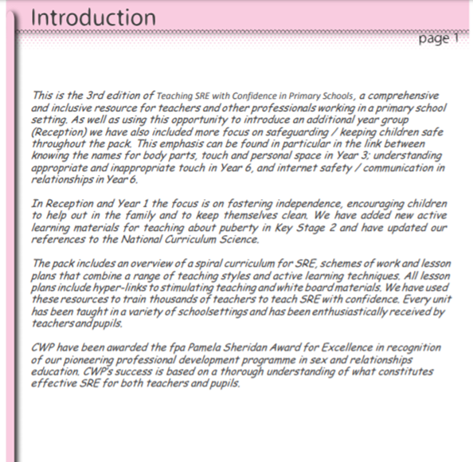

Appendix 3: Tips for Teaching SRE with Confidence
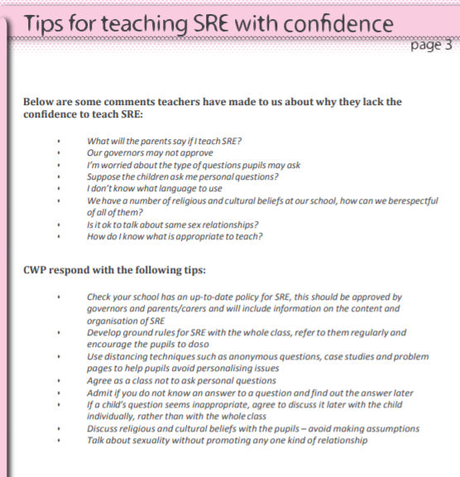

Appendix 4: Christopher Winter Curriculum Overview

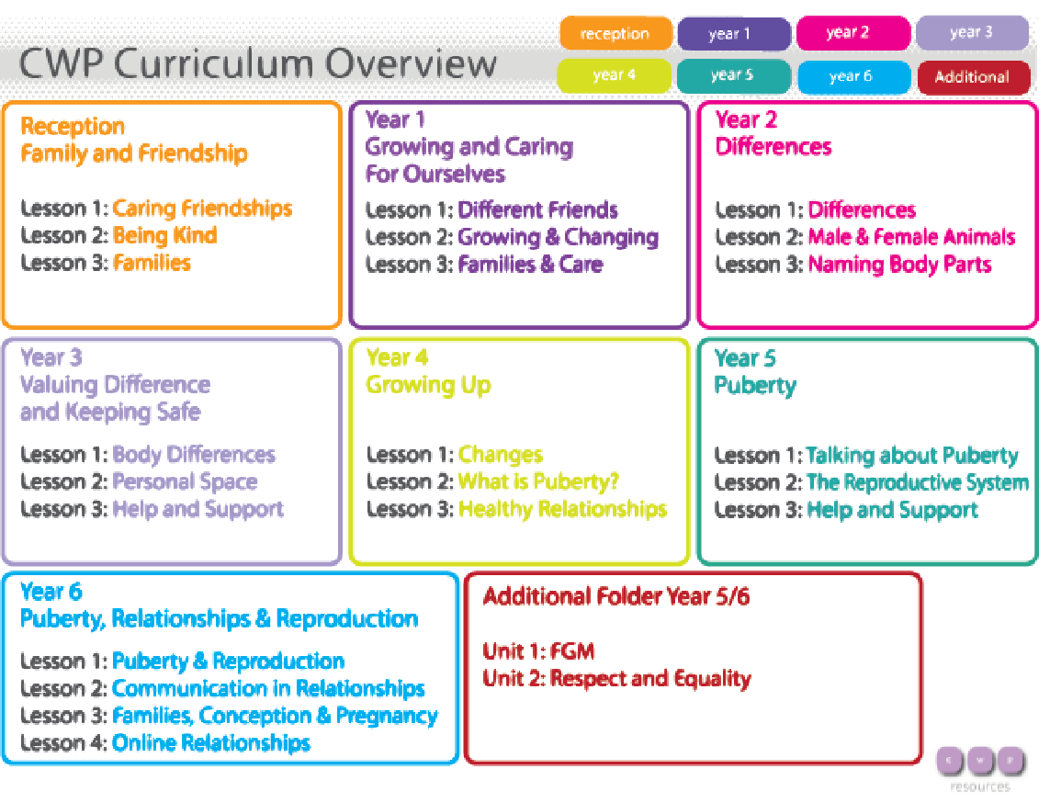

Appendix 5: A Charter for faith sensitive and inclusive relationships education, relationships and sex education (RSE) and Health Education (RSHE)

In The Academy for Character and Excellence we seek to provide Relationships Education, Relationships and Sex Education (RSE) and Health Education (RSHE), which will enable all pupils to flourish.

We commit:
- To work in partnership with parents and carers. This will involve dialogue with parents and carers through all stages of policy development as well as discussing the resources used to teach their children and how they can contribute at home. It must, however, be recognised that the law specifies that what is taught and how it is taught is ultimately a decision for the school.

- That RSHE will be delivered professionally and as an identifiable part of PSHE. It will be led, resourced and reported to parents in the same way as any other subject. There will be a planned programme delivered in a carefully sequenced way. Staff will receive regular training in RSHE and PSHE. Any expert visitors or trainers invited into the school to enhance and supplement the programme will be expected to respect the schools published policy for RSHE.

- That RSHE will be delivered in a way that affords dignity and shows respect to all who make up our diverse community. It will not discriminate against any of the protected characteristics in the Equality Act and will be sensitive to the faith and beliefs of those in the wider school community. RSHE will seek to explain fairly the tenets and varying interpretations of religious communities on matters of sex and relationships and teach these viewpoints with respect. It will value the importance of faithfulness as the underpinning and backdrop for relationships. It will encourage pupils to develop the skills needed to disagree without being disagreeable, to appreciate the lived experience of other people and to live well together.

- That RSHE will seek to build resilience in our pupils to help them form healthy relationships, to keep themselves safe and resist the harmful influence of pornography in all its forms. It will give pupils opportunities to reflect on values and influences including their peers, the media, the internet, faith and culture that may have shaped their attitudes to gender, relationships and sex. It will promote the development of the wisdom and skills our pupils need to make their own informed decisions.

- That RSHE will promote healthy resilient relationships set in the context of character and virtue development. It will reflect the vision and associated values of the school, promote reverence for the gift of human sexuality and encourage relationships that are hopeful and aspirational. Based on the school’s values it will seek to develop character within a moral framework based on virtues such as honesty, integrity, self-control, courage, humility, kindness, forgiveness, generosity and a sense of justice but does not seek to teach only one moral position.

- That RSHE will be based on honest and medically accurate information from reliable sources of information, including about the law and legal rights. It will distinguish between different types of knowledge and opinions so that pupils can learn about their bodies and sexual and reproductive health as appropriate to their age and maturity.

- To take a particular care to meet the individual needs of all pupils including those with special needs and disabilities. It will ensure that lessons and any resources used will be accessible and sensitive to the learning needs of the individual child. We acknowledge the potential vulnerability of pupils who have special needs and disabilities (SEND) and recognise the possibilities and rights of SEND pupils to high quality relationships and sex education.

- To seek pupils’ views about RSHE so that the teaching can be made relevant to their lives. It will discuss real life issues relating to the age and stage of pupils, including friendships, families, faith, consent, relationship abuse, exploitation and safe relationships online. This will be carefully targeted and age appropriate based on a teacher judgment about pupil readiness for this information in consultation with parents and carers.

Appendix 6: Parent withdrawal form from sex education within RHSE

TO BE COMPLETED BY PARENTS
Name of child |  | Class
Name of parent |  | Date
Reason for withdrawing from sex education within relationships, health and sex education
Any other information you would like the school to consider
Parent signature

TO BE COMPLETED BY THE SCHOOL
Agreed actions from discussion with parents

RSHE is used to indicate either Relationships Education, Relationships and Sex Education and Health Education as determined by the school context since, after consultation with parents and carers primary schools may decide to include elements of sex education in their curriculum.
The protected characteristics are age, disability, gender reassignment, race, religion or belief, sex, sexual orientation, marriage and civil partnership and pregnancy and maternity.

