Torre C of E Academy Reception Long-Term Planner
Autumn 1 |  |  | Autumn 2 |  | Spring 1 |  |  | Spring 2 |  | Summer 1 |  |  |  |  | Summer 2
Citizenship - Compassion  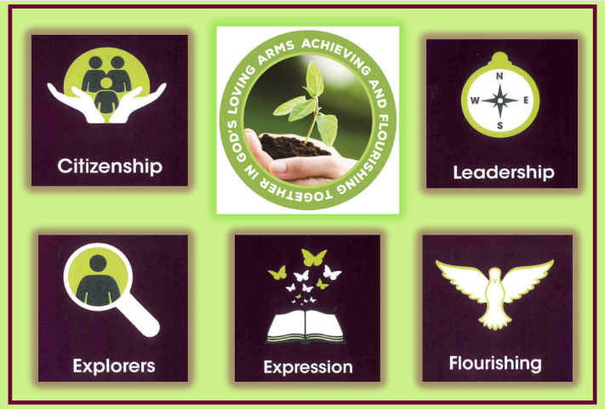 |  |  | 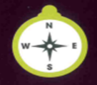  Leadership-Determination/  Integrity |  |   Exploration -Aspiration/Resilience |  |  | 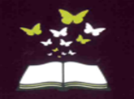  Expression - Confidence/Honesty |  | 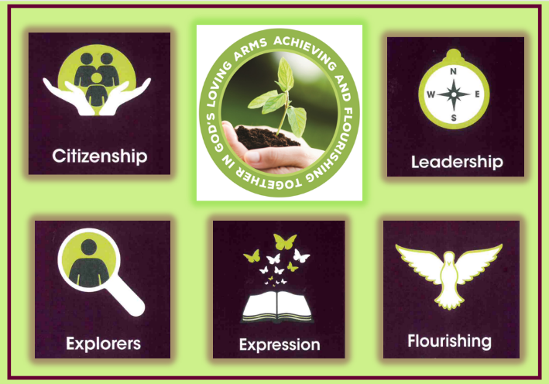  Flourishing -Responsibility/Courage |  |  |  |  |   Citizenship-Drive
Year Group Key Knowledge and Skills
PSED  3 Weeks | UW/EAD  PSED and  DT  3 weeks | UW/EAD  Science and Music  3 weeks |  | UW  Geography  3 weeks |  | UW  History  3 weeks | UW  Geography  3 weeks | UW  Science  3 weeks | EAD  Art  3 weeks | UW/EAD  Music and DT  3 weeks | UW  Science  3 weeks |  |  |  | EAD  Art  3 weeks | UW  History  Narrative  3 weeks
I know what a family is.  I know the names of some feelings .  I know how to associate feelings with words.  I know what a healthy relationship looks like.  I know what a friend is.  I know how to be kind to others. | I know what healthy means.  I know why it is important to brush my teeth.  I know what is healthy or unhealthy.  I can make healthy food choices.  I know where food comes from.  I know how to wash my hands.  I know how to cook apron/hair.  I can brush my teeth accurately. | I know daily weather patterns.  I know the 4 seasons.  I know summer is hot and winter is cold.  I know how to keep warm and stay cool.  I know some important changes in the natural world around me including the seasons.  I know the difference between speaking and singing.  I can create some sounds with a group of people. |  | I know some simple features of my immediate environment.  I know the location my school is situated in.  I know some important places where I live.  I know what a map is and why we use them.  I can use aerial maps and photos to comment on simple features.  I can draw a simple map. |  | I know something that my parents remembered from their childhood  I know what a memory is  I know and can recall memories  I know that memories are from the past and that they are real | .I know not all homes are the same.  I know places can be different.  I know the world is round.  I know environments vary from one another.  I know about similarities and differences between places e.g. countryside and town. | I know if something is alive or dead.  I know how to care for something living.  I know how to recognise a young plant and an older plant.  I know I need to respect and care for the natural environment, animals and all living things.  I know how seeds and bulbs grow into plants.  I know we need sunlight to create a shadow. | I know the effects of mark making.  I know the names of colours.  I know how to use tools including hands and fingers to apply paint.  I know how to mix colours.  I know how to hold and use pencils.  I can create with a purpose in mind.  I can explain how I made something. | I know different materials make different sounds.  I know that music can affect the way I feel.  I know the names of some instruments.  I can create sounds using a variety of methods.  I can suggest how I might make something.  I can talk about a product.  I know tools can help me. | I know some facts about animals and plants through observations.  I know I need to respect and care for the natural environment.  I can make scientific suggestions.  I know some properties of materialising.e.g. soft, hard, bendable and magnetic. |  |  |  | I know how to combine materials.  I know the effect of cutting materials.  I know the importance of plan, do and review.  I know how to create with a purpose in mind.  I know some facts about animals and plants through observations.  I know that humans can have a positive and negative impact on our world. |  | I know the meaning of some vocabulary linked to stories.  I know what a character is.  I know what a setting is.  I know I need to listen attentively to answer questions about a story.  I can say what I see in a picture.
Enquiry Question
What makes me special? | How can I keep myself healthy? | What can we see and hear in the four seasons? |  | Where do my wellies take me? | Why are memories important? |  | Where do others live? | What signs of new life can I see? | How can I create a rainbow of colour? | What materials can I use to make interesting sounds? |  | What materials would make a brilliant bug hotel? |  | How can we make a difference to our blue planet? |  |  | How did Grace Darling show compassion for others?
Outcomes and experiences
To make a special book about my life and share it with my family and friends. | To make a healthy snack. | To create a piece of music for each season. |  | To make a photo map of the school. | To make a memory scrapbook. |  | To design your own home. | To grow a plant for Mother’s Day. | To make a painting for our gallery. | To design and make a musical instrument. |  |  | To construct a bug hotel. |  | To construct a sea creature from recycled materials. | To write a message to Grace Darling.
Religious and Worldviews Education
Being Special |  | Incarnation - Why do Christians perform nativity plays at Christmas? |  |  | God/Creation - Why is the word ‘God’ so important to Christians? |  |  | Salvation - Why do Christians put a cross in the Easter Garden? |  | Special Places |  |  |  |  | Special Stories
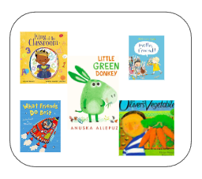 |  | 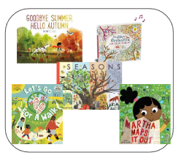 |  |  | 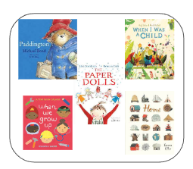 |  |  | 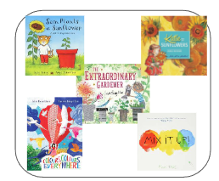 |  | 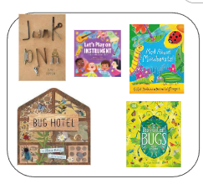 |  |  |  |  | 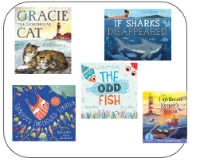
Teaching of Other Subjects
Religion and Worldviews – a core subject taught weekly Computing - taught weekly PE/Games - taught weekly

