materu
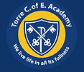
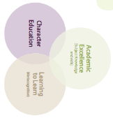

Torre C of E Academy Long Term Planner Year 3/4 Year A 2024/2025
Autumn 1 – Independence |  | Autumn 2 – Creativity |  |  |  | Spring 1 - Collaboration |  |  | Spring 2 – Independence |  |  | Summer 1 – Creativity |  | Summer 2 - Collaboration
Citizenship - Drive  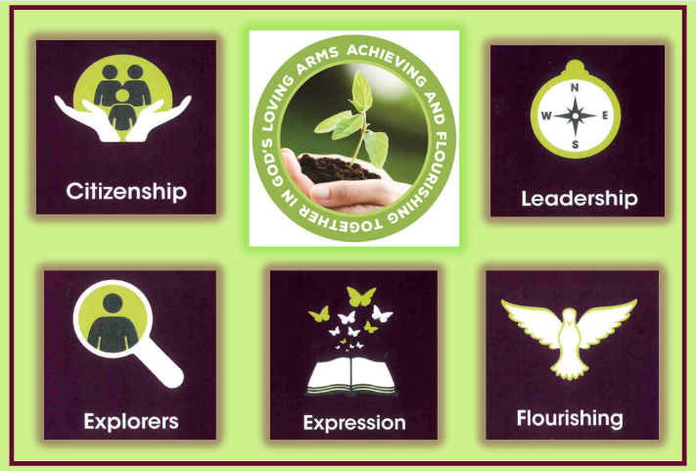 |  | 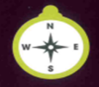  Leadership - Determination |  |  |  |   Exploration - Aspiration |  |  | Expression - Confidence  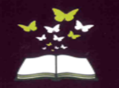 |  |  | Flourishing - Responsibility  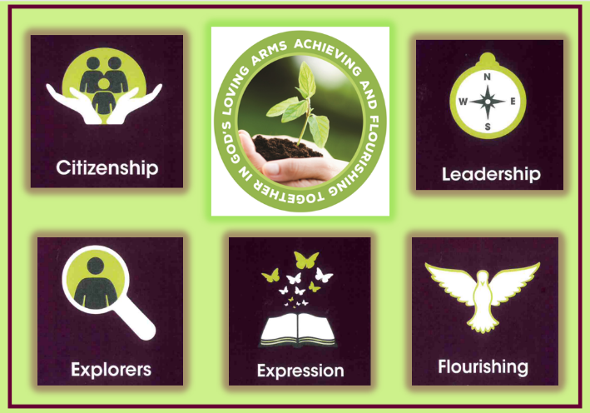 |  | Citizenship-Compassion  
Year Group Key Knowledge and Skills
RSHE | Geography | Science | History | Music/Narrative |  | RSHE | History | Science | Narrative | Art | DT | Geography | Science | Art | Music | DT | RSHE
Friends/Family  (focus on family) | Regions of the UK | Animals including humans - nutrition and skeleton | Romans | Christmas  Fiction - The Snowman  Sing from Memory |  | Money Matters | Viking Raids and Saxon Settlements | Rocks and Fossils | The Great Elephant Chase | Printing - William Morris | I can make something that is being trailled | European Countries and Regions | Solids, liquids and gases | Drawing and painting | Accompany a tune using simple transcription | Seasonal / local | Relationship Education  Safety  SRE
Key Enquiry Question
What does family mean around the world, and how can we care for our own? | What are the advantages to rural living? | How and why is my skeleton different to a reindeer? | What did the Romans do for us? | How does Raymond Briggs use sensory details to bring ‘The Snowman’ story to life and help you connect with the setting and characters?  What is the importance of Carols at Christmas time? |  | Why do we use money and how does it help people in their daily lives? | Why was Alfred the great so great? | What can I teach people about rocks and fossils? | What devices do I need to use to develop settings successfully in a story? | How can I use printing techniques to design a new front cover for The Great Elephant Chase? | How do I make a prototype greenhouse? | Which region of France would I prefer to visit on holiday? | How does temperature affect the water cycle? | How can I develop as an artist by studying the work of Vincent Van Gogh? | Which musical instruments would you use to depict a Twits character? | What local and seasonal produce can I use to create a soup recipe for others to follow? | Y3 - How do our bodies differ?  Y4 - How do our bodies change?
Writing Genre and Outcomes
A diary entry /reflection or student’s own family and how they can show care with a comparison.  Link text - A Ticket Around the World by Natalia Diaz & Melissa Owens | A letter | An interactive page comparing a human and a reindeer diet and skeleton. | Non-chronological report detailing the impact the Romans had on our lives. | Use sensory details to create an original festive setting for the Snowman to visit | To perform a verse of a Christmas carol as a group. | Informative leaflet | Write to justify their opinions based on historical evidence. | An informative illustrated mind map | Fiction prose | A relief print designing a new front cover for The Great Elephant Chase. | A prototype greenhouse | Brochure/Leaflet | Investigation – report writing | Painting in the style of Vincent Van Gogh. | Musical piece using instruments and voice to match invented Twits characters personality. | Soup - Recipe writing | Christopher Winter outcomes
Religious and Worldviews Education
PEOPLE OF GOD (UC)  What is it like to follow God? |  | GOSPEL (UC)  What kind of world did Jesus want? |  |  |  | HINDUS  Unit L2.7 D&T Agreed Syllabus  What do Hindus believe God is like? |  |  | INCARNATION/  GOD (UC)  What is the Trinity? |  |  | HINDUS  Unit L2.8 D&T Agreed Syllabus  What does it mean to be a Hindu in Britain today? |  | LIFE AS A JOURNEY  Unit L2.11 D&T Agreed Syllabus  How and why do people mark the significant events of life?  (Christians, Hindus, Muslims and non-religious worldviews)
Teaching of other subjects:
Maths - a core subject taught daily for one hour Reading - a core subject taught daily for one hour Handwriting - daily for 15 minutes due to need in KS2
French - taught weekly or blocked 3/4 sessions per half term Computing - taught weekly or blocked 3/4 sessions per half term Grammar - taught weekly in KS2 for one hour
PE/Games - including swimming in Y3/4 taught weekly (2 hours)

Torre C of E Academy Long Term Planner Year 3/4 Year B 2025/2026

Autumn 1 – Independence |  |  | Autumn 2 – Creativity |  |  |  | Spring 1 - Collaboration |  |  |  | Spring 2 – Independence |  |  |  | Summer 1 –Creativity |  | Summer 2 - Collaboration
Citizenship - Drive |  |  | Leadership - Integrity |  |  |  | Exploration - Resilience |  |  |  | Expression - Honesty |  |  |  | Flourishing - Courage |  | Citizenship-Compassion
Year Group Key Knowledge and Skills
RSHE | Geography | Science | Science | DT | Music | Narrative  Writing | RSHE | History | Science | DT | Narrative Writing | Music | Geography | Art | Science | History | Art | Science | RSHE | Narrative Writing
Friends and Family  (focus on friends) | Contrasting Regions of the UK | Forces and Magnets | Electricity  I can make something that is being tested . |  | A language of Music, technical terms and performance | Christmas  Poetry | Money Matters  YR3/4 | Stone Age  Iron Age | Light and Sound | Make something for a purpose | The Magic Faraway Tree | Design, compose annotate | Contrasting a non-European region at risk | Sculpture | Animals inc human  Teeth and digestion | Historical Impact - Tudors or Victorians | Drawing and Painting  Laura Wall | Living Things - Plants and Animal | RSHE  Safety  SRE | La Luna - Descriptive writing
Key Enquiry Question
What positive traits does a friend have and why do they need them? | In which region of the UK would you like to visit and why? | How can I use forces to my advantage? | How do I create a working light box/night light? |  | What musical skills do we need to create a musical, atmospheric soundscape? | How can I invent a traditional Christmas tale? | Can I explain where money comes from? | How did the earliest living humans survive? | How does light travel and how are sounds made? | How can I make the tastiest Greek salad? | Can I successfully develop a fiction story? | What expertise to do I require? | Why was the Haiti earthquake so catastrophic? | How an I use my sculpting skills to create an Iron Age tool or piece of jewellery? | How does my digestive system work? | What is a historical impact of Victorians? | Why is Laura Wall such an inspirational artist? | How do plants grow, survive, and adapt to their environment? | Y3 - How do our bodies differ?  Y4 - How do our bodies change? | Why was Luna’s quiet night on the ocean so special?
Writing genre and outcome
Own story about friendship (The Invisible Boy) | Persuasive text | Write up of scientific experiment | A light box/Night light |  | Create a soundscape for a pictorial stimulus | Christmas story  (narrative) | Presentation  Computing | Non-chronological report | Explanation text | A Greek salad. | Fiction prose | Compose music from around the world. | Non-chronological report | Tool/Jewellery  Reflection | Information text | Historical fiction  *Speech writing | Laura Wall painting | Explanation text | Christopher Winter  Outcomes | Descriptive writing La Luna
Religious and Worldviews Education
CREATION/FALL (UC)  What do Christians learn from the creation story? |  |  | MUSLIMS  Unit 1.6 D&T Agreed Syllabus  Who is a Muslim and how do they live?  (Part 2 From page 9)  Unit L2.9 D&T Agreed Syllabus  What difference does worshipping God make to Muslims? |  |  |  |  | SALVATION (UC)  Why do Christians call the day Jesus died ‘Good Friday’? |  |  |  |  | KINGDOM OF GOD (UC)  When Jesus left, what was the impact of Pentecost? |  | MUSLIMS  Unit 2.9 D&T Agreed Syllabus  How do festivals and worship show what matters to a muslim? |  | A BETTER PLACE  How and why do people try to make the world a better place?  (Christians, Muslims, non-religious worldviews)
Teaching of other subjects:
Maths - a core subject taught daily for one hour Reading - a core subject taught daily for one hour Handwriting - daily for 15 minutes due to need in KS2
French - taught weekly or blocked 3/4 sessions per half term Computing - taught weekly or blocked 3/4 sessions per half term Grammar - taught weekly in KS2 for one hour
PE/Games - including swimming in Y3/4 taught weekly (2 hours)

