Year 2 Statistics Learning Organiser
Concepts | Knowledge | Vocabulary
  Strategy | 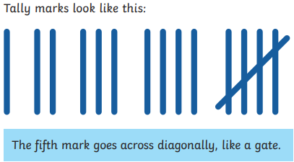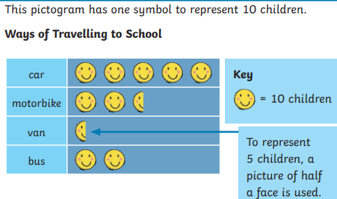 | Data  Interpret  Key  Tally chart  Pictogram  Block diagram  Table  Total  Compare  Symbol
  Clarify | 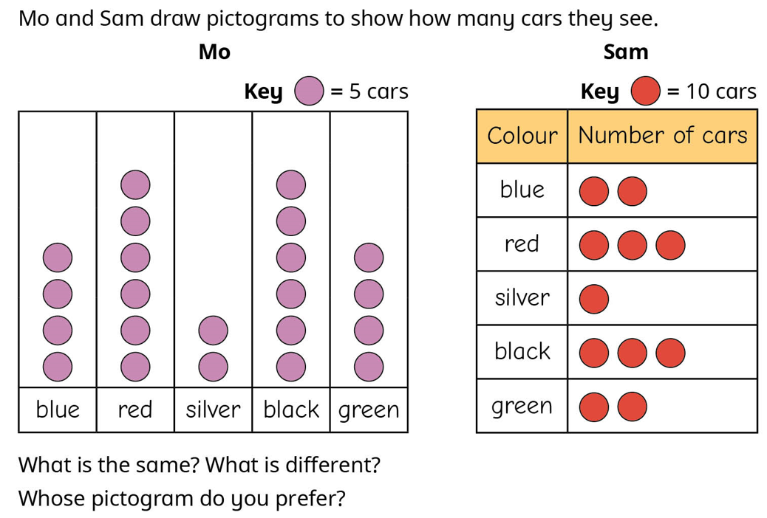  The symbol for the key is the same but the value of the circle is different. I prefer Sam’s as it is quicker to work out how many cars are a certain colour.
  Deconstruct | 