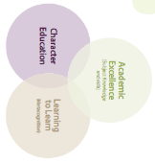

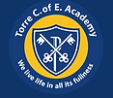
Torre C of E Academy Long Term Planner Year 1/2 Year A 2024-25
Autumn 1 – Independence |  |  | Autumn 2 – Creativity |  |  | Spring 1 - Collaboration |  | Spring 2 – Independence |  |  | Summer 1 – Creativity |  | Summer 2 - Collaboration
Citizenship-Compassion  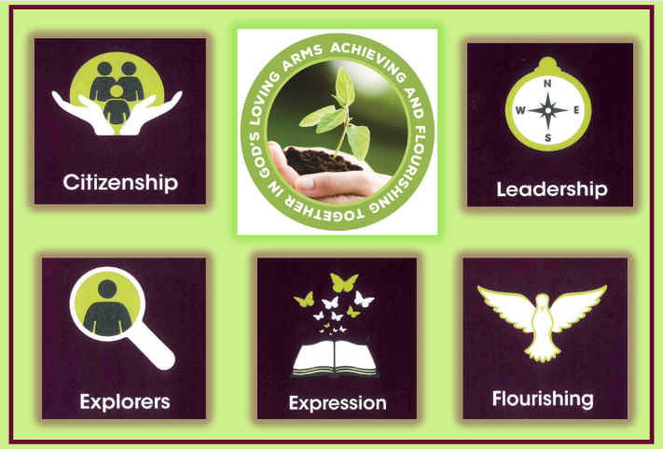 |  |  | 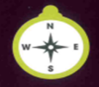  Leadership-Determination |  |  | Exploration -Aspiration   |  | 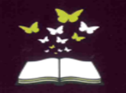  Expression - Confidence |  |  | 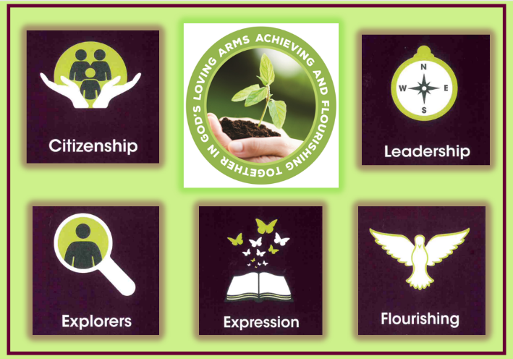  Flourishing - Responsibility |  | Citizenship-Drive    l
Year Group Key Knowledge and Skills
RSHE |  | Geography | Science | DT | Narrative | History | Science | Narrative | Music | Art | Geography | Science | History | Music | RSE | DT
RSHE  Friends and Family |  | Geography - The Area I Live In  Art- Textiles Weaving and Collage | Science Food Chains | Design Technology Making something with a purpose | Narrative | History- changes in my life | Science - Living Things plants | Narrative- Jack and the Beanstalk | Music - Singing Create an effect Pattern, Pitch and sounds | Art - Drawing and Painting | Geography - UK Contrasting Locality | Science - Habitats | History - Significant Events UK Great Fire of London | Music - Composition Making choices to create an effect | RSHE - Safety  Christopher Winter resources | DT - Make something to be measured and weighed  Overnight oats
Key Enquiry Question
How can we show care for others? |  | What makes Torbay a bay and why is it popular with tourists? | What is a food chain? | How are Christmas decorations made? | What makes the Christmas story special? | Which childhood would you choose: yours, your parents or your grandparents? | What does a plant need to flourish? | What makes a traditional fairy tale popular? |  | How is colour used in art? | Why is London a popular city with tourists? | Why do certain animals need to be in certain habitats? | What would it have felt like to witness the Great Fire of London? | How can our bodies create music? | Y1 - How are families the same and different?  Y2 - How are male and female’s bodies different? | What makes the best tasting overnight oats?
Writing Genre and Outcome
Write my own story about family and friendship, showing care  (Storm Whale) |  | Persuasion - Come to Torbay!  A weaving reflecting the colours of the bay. | A food chain model. | Design and create a Christmas tree decoration | A retelling of the First Christmas | A report comparing which is or was the better childhood. | A guide to a healthy plant for the Community Garden. | Present a fairy tale through writing and song. |  | A vase of flowers painting. inspired by Yayoi Kusama. | London Landmarks Slideshow. | Animal Folktales in the style of Rudyard Kipling Just So stories. | A diary entry writing to describe the Great Fire of London | A body percussion performance for the song ‘London’s Burning’. | Christopher Winter outcomes | Instructions  Overnight oats
Teaching of Other Subjects
Religion and Worldviews – a core subject taught weekly Music- taught as separate learning enquiry or within another MFL-weekly lessons using the PLN French Programme
PE/Games including swimming in KS2 taught weekly Computing - Taught weekly

 | Autumn 1 | Autumn 2 | Spring 1 | Spring 2 | Summer 1 | Summer 2
Year 1/2 (A) | GOD (UC)  What do Christians believe God is like? | INCARNATION (UC)  Unit 1.3  Why does Christmas matter to Christians? | JEWISH WAY OF LIFE  Unit 1.7 D&T Agreed Syllabus  Who is Jewish and how do they live? | SALVATION (UC)  (Digging Deeper)  Why does Easter matter to Christians? | JEWISH TRADITIONS  Unit 1.7 D&T Agreed Syllabus  How is Shabbat celebrated in a Jewish home? | CARING  Unit 1.9 D&T Agreed Syllabus  How should we care for others and for the world, and why does it matter?  (Christians, Jews and non-religious worldviews)

Torre C of E Academy Long Term Planner Year 1/2 Year B 2025-26
Autumn 1 – Independence |  |  | Autumn 2 – Creativity |  |  | Spring 1 -Collaboration |  |  | Spring 2 – Independence |  |  | Summer 1 – Creativity |  | Summer 2 - Collaboration
Citizenship-Compassion |  |  | Leadership-Integrity |  |  | Exploration -Resilience |  |  | Expression -Honesty |  |  | Flourishing - Courage |  | Citizenship- Drive
Year Group Key Knowledge and Skills
RSHE |  | Geography | Science | Art | Narrative | History | Science | Music | DT | Narrative | Music | Science | History | Geography | RSE | Art | DT
RSE - Friends and Family |  | Geography - My Locality | Science - Materials | Art - Sculpture  Fab Five Link:  The Smartest Giant in town | Stories with familiar settings  Fab Five Link: Dogger | History - Life of others  Floella Benjamin | Science - Seasonal Changes | Music Composition Play and explore with pattern, pitch and depth | Design and Technology - Make something to be cooked | Fairy tales  Little Red Riding Hood | Music - Beat and Rhythm  LRRH | Science - Animals Including Humans | History - Significant Local Events Kent’s Cavern (Year 2) | Geography - UK Countries of UK, Capital Cities, Features | RSE - Safety | Science - Microhabitats  Art - Insect Drawing | Making something that works  Moving Pict
Key Enquiry Question
Who are my VIPs? |  | How can I describe my locality? | Which materials would be most suited to make an outdoor sculpture? | Which materials would be most suited to make an outdoor sculpture? | How can I make my story interesting to the reader? | What is the significance of Floella Benjamin coming to England? | How do seasonal changes affect people and animals? |  | How can I aspire to make the best pizza for the Great Cooking challenge? | What makes a traditional fairy tale popular? |  | How do awesome offspring grow into healthy adults? | How has Kent’s cavern been used from the Stone Age to today? | How is the United Kingdom divided but still united? | 1 - How are families the same and different2 - How are male and female’s bodies different | What makes an insect so incredible to draw? | What mechanisms can be used in moving pictures?
Writing Genre and Outcome
A speech for my VIP |  | Wild Woodland Walk description | A big nature sculpture. | A big nature sculpture. | Own lost toy story. | Writing - fact file of Floella Benjamin. | A musical performance explaining the changes in weather for the seasons. |  | Instructions to make a pizza. | Present a fairy tale through writing and song. |  | Guide to how to look after a chosen pet. | An interactive timeline for an exhibition. | An interactive map of the UK. | Christopher Winter outcomes | A realist drawing of an insect. | A moving picture using my chosen mechanism.
Teaching of Other Subjects
Religion and Worldviews – a core subject taught weekly Music- weekly lessons using the Charanga programme MFL-weekly lessons using the PLN French Programme
PE/Games including swimming in KS2 taught weekly Computing - Taught weekly

 | Autumn 1 | Autumn 2 | Spring 1 | Spring 2 | Summer 1 | Summer 2
Year 1/2  (B) | BELONGING  Unit 1.10 D&T Agreed Syllabus  What does it mean to belong to a faith community?  (Christians, Jews, Muslims and non-religious worldviews) | CREATION (UC)  Who do Christians say made the world? | MUSLIMS  Unit 1.2 D&T Agreed Syllabus  Who is Muslim and what do they believe?  (Part 1 - up to page 8) | SALVATION (UC)  Why does Easter matter to Christians? | GOSPEL (UC)  What is the good news that Jesus brings? | SACRED PLACES  Unit 1.8 D&T  Agreed Syllabus  What makes some places sacred to some believers?  (Christian and Muslim)

