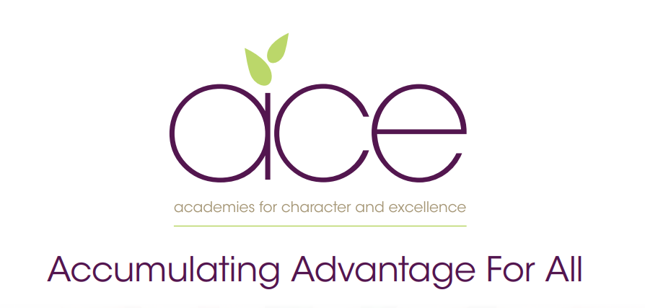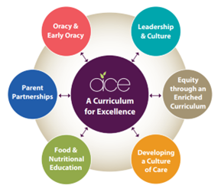

**Torre C of E Academy**

**Pupil premium strategy statement**

**2025–2026**

This statement details our school’s use of pupil premium funding to help improve the attainment of our disadvantaged pupils. 

It outlines our pupil premium strategy, how we intend to spend the funding in this academic year and the effect that last year’s spending of pupil premium had within our school. 

**School overview**

|  |  |
| --- | --- |
| **Detail** | **Data** |
| School name | Torre C of E Academy |
| Number of pupils in school | 317 (294 without Pre-School) |
| Proportion (%) of pupil premium eligible pupils | 24.4% (72) |
| Academic year/years that our current pupil premium strategy plan covers **(3 year plans are recommended)** | 2024–2027 |
| Date this statement was published | October 2024 |
| Date on which it will be reviewed | November 2025 |
| Statement authorised by | Governing body |
| Pupil premium lead | Rachel Cowell |
| Governor / Trustee lead | James Millar |

**Funding overview**

|  |  |  |
| --- | --- | --- |
| **Detail** | | **Amount** |
| Pupil premium funding allocation this academic year | £112,110 | |
| Pupil premium funding carried forward from previous years (enter £0 if not applicable) | £0 | |
| **Total budget for this academic year**  If your school is an academy in a trust that pools this funding, state the amount available to your school this academic year | £112,110 | |

**Part A: Pupil premium strategy plan**

|  |
| --- |
| * *See our Trust wide* ***plan ‘Accumulating Advantage for all’***   In a changing world we recognise the need to ensure that our Curriculum reflects how pupils are supported and encouraged to flourish in all aspects of their lives. Current research shows that the South West is one of the most challenging areas to grow up poor. We strongly believe that as a Trust, and through our Curriculum, we are able to narrow the disadvantaged gap, supporting all pupils. |

**Our aims for our disadvantaged pupils**

* Our aim as a Trust is to ensure that all pupils accumulate advantage based on the high quality experience that we offer them through our Curriculum and enquiry based approach to learning.
* Our Curriculum is rich and ambitious and offers all pupils an equal opportunity to experience a range of outdoor lessons, take part in educational visits, theatre trips, hands-on days, expert visits and have the opportunity to explore a wide range of extra-curricular clubs.
* We believe that all pupils should have the opportunity to aspire to be the best version of themselves, therefore we provide pupils with the experiences that develop their love of learning and support them to acquire experiences as they move through their school lives, to make informed choices when deciding future decisions.

**Statement of Intent**

At the heart of our curriculum lie three core values: pursuit of academic excellence; the explicit teaching of learning to learn, which includes the development of metacognition; and crucially, character education. We believe that through our curriculum and core principles we can ensure that our very high expectations result in improved outcomes for disadvantaged pupils. This ensures all children will achieve and flourish whilst acquiring life longs skills that enable learners to overcome any barriers to learning and future successes.

**Objectives for our disadvantaged Pupils**

* We will ensure that the progress of our disadvantaged children will equal or exceed those who are not disadvantaged by implementing our strategy plan. The ACE curriculum plays a central and critical role in accumulating advantage for all pupils, including those that are presently or previously experiencing disadvantage.
* All disadvantaged pupils will be equipped, academically, socially, culturally and emotionally to continue to make progress at their Secondary schools and beyond. Our aim is to ensure that all children leaving our schools are successful learners, curious explorers and healthy thinkers.

**Our current pupil premium plan focuses on the following goals** (***see ‘Accumulating advantage for all’*** booklet for more detail)

Strong Leadership that drives:

* Equity through an enriched curriculum (including high quality, well researched and impactful interventions)
* A culture of high quality care
* Food and Nutritional Education
* Effective parent/carer partnerships
* Development of Early Oracy and ongoing oracy skills

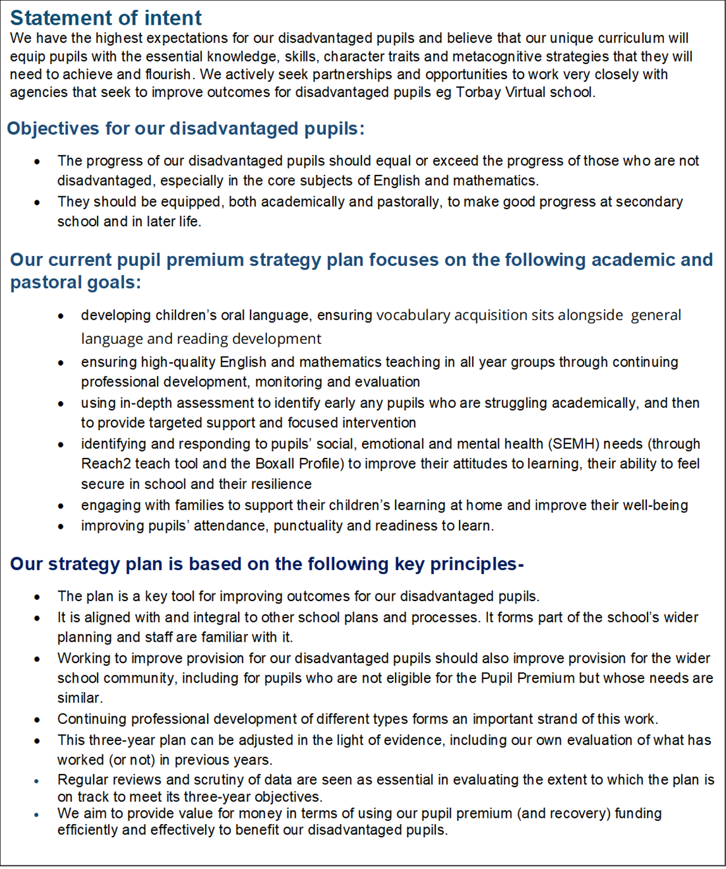

**Challenges**

This details the key challenges to achievement that we have identified among our disadvantaged pupils.

|  |  |
| --- | --- |
| **Challenge number** | **Detail of challenge** |
| 1 | Assessments, observations, and discussions with pupils indicate underdeveloped **oral language skills** and **vocabulary gaps** among many disadvantaged pupils. These are evident from Reception through to KS2 and in general, are more prevalent among our disadvantaged pupils than their peers. |
| 2 | Assessments, observations and discussions with pupils show that disadvantaged pupils do not typically have the same **cultural awareness** and **aspirations** as some of our non-disadvantaged pupils. |
| 3 | Assessments, observations and discussions with pupils and families have identified **social and emotional issues** for many pupils, notably due to a lack of enrichment opportunities and appropriate socialisation opportunities, challenges particularly affect disadvantaged pupils, including their attainment.  Many children across the school – including disadvantaged children, need support with play and dealing with disagreements in the playground. |
| 4 | Across all year groups the disadvantaged gap is the largest in writing. Some of our pupils struggle with **written tasks** and have negative attitudes towards sustained pieces of writing. Our ACE curriculum is allowing us to challenge these mindsets, although writing outcomes are lower across the school than other subjects |
| 5 | Absence and **persistent absence** is a significant contributing factor to our pupil premium children not achieving as well as non-pupil premium children. Average attendance for this group of pupils is currently **94.4%.** |
| 6 | 36% of children on our PP register are our most vulnerable disadvantaged pupils have had **previous trauma** in their lives and this continues to impact on their lives. |

**Intended outcomes  *- see ‘Accumulating Advantage for all’***

|  |  |
| --- | --- |
| **Intended outcome** | **Success criteria** |
| * **A Curriculum for Excellence**   The ACE curriculum is ensuring QFT is making a difference for our disadvantaged pupils and progress measures show the gap between disadvantaged and others is closing | * As a result of careful and focused monitoring our PP pupils are becoming successful learners * Journals reflect progress made in all three areas- metacognition, character education and academic excellence (see individual PP tracker) * The progress of disadvantaged pupils is at least the same as the progress of non-disadvantaged pupils and no greater than a 10% difference by the end of KS2 * As a result of a range of intervention and strong phonics teaching, disadvantaged pupils make accelerated and sustained progress in all writing tasks. * Pupils at risk of underachieving in Year 6 have a teacher mentor on a 1:1 basis and receive x2 sessions per week of 20 minutes. * Additional tuition and intervention is provided in all year groups to PP pupils as a priority. |
| * **Oracy and Language Acquisition**   All disadvantaged pupils have improved oracy skills and are increasingly able to communicate effectively | * Language link programme demonstrates improved language skills * Oracy approach (across the curriculum) is evident in terms of key outcomes for pupils * Our reading strategy is ensuring that by the time children reach Y6 all children are at least at the expected standard, including those on our SEND register * PP children are read with daily, prioritised by class teachers and TA’s. Pre-teach of vocabulary is introduced to children and explained prior to provide more opportunities for children to be successful. * Vocabulary is explicitly taught through quality first teaching and is planned for by class teachers in all subjects. All classes regularly using the ‘vocab cards’ to ensure retrieval of learnt vocabulary. * Knowledge game boards are used to continuously revisit and engage with content and concepts. Visuals are used to support children with this along with collaborative practice. |
| * **Enrichment opportunities** are providing pupils with the skills and knowledge to become more successful learners | * Take up of ASCs is high and pupils are clearly gaining through these experiences * Where ASCs are full or oversubscribed, PP children are given priority over their non-disadvantaged peers. * All disadvantaged pupils attend residentials, which are partly funded by the school * The school seeks meaningful opportunities to broaden pupils horizons eg visiting authors, musical workshops and innovative subject days at our local Secondary schools * PP children are prioritised for trust wide events such as the ACE Olympics, Maths Enrichment Day and swimming galas. |
| * **High quality care** through SEMH support is ensuring excellent wellbeing and readiness for learning | * Pupil outcomes have improved in all areas (academically, socially, emotionally, culturally) * Pastoral support is well matched to individual need * Soft data (BOXALL) demonstrates that identified pupils are developing their ability to understand and regulate their emotions. |
| * **Food and Nutrition**   Pupils and families have opportunities in school to participate in workshops and clubs to improve health through food and nutrition education | * All pupils will have access to free breakfast on entry to school every morning through the National Breakfast programme. * Families invited to a ‘family bake’ session to learn about cooking nutritious foods on a budget * Children take part in food technology sessions where they develop their cooking skills * PP children have access to high quality food throughout the school day, being hungry in school is never an issue. |
| * **Parent/carer partnerships** are strong and parents are increasingly able to support their children’s well being and learning | * Improve attendance of disadvantaged pupils to 95% * Prioritise parent meetings and workshops for children with insufficient resources * Continue to ensure all parents take part in learning enquiry outcomes where parents have the opportunity to share learning, journals and other engaging outcomes. * 90% of parents when surveyed will state that they feel confident supporting their child’s learning at home through access to our regular parent workshops. * Meetings with the SENDCO, class teacher and EP will be well attended by PP families. * Parent/carer forums will be well attended by our PP families and individual communication and invites will support this. |

**Activity in this academic year**

**Teaching (for example, CPD, recruitment and retention)**

Budgeted cost: £ 33,717 (HLTA £15,769 and SLT member 0.5 £17,948 )

35896

5546

10223.62

|  |  |  |
| --- | --- | --- |
| **Activity** | **Evidence that supports this approach** | **Challenge number(s) addressed** |
| 1. Use of language link and other oracy strategies to develop communication skills in the Early Years and KS1 | Early Reading framework – Section 2: developing Talk and Appendix 2  EEF – [Oral Language Interventions](https://educationendowmentfoundation.org.uk/education-evidence/teaching-learning-toolkit/oral-language-interventions) | 1,4 |
| 1. Deliver impactful and bespoke nurture sessions that allow pupils to develop strategies around social skills, self regulation and self expression | EEF social and emotional learning  <https://educationendowmentfoundation.org.uk/education-evidence/evidence-reviews/social-and-emotional-learning> | 3 |
| 1. Provide extended opportunities for pupils, ensuring all disadvantaged pupils have wider opportunities to take part in art, sports, music clubs | EEF social and emotional learning  <https://educationendowmentfoundation.org.uk/education-evidence/evidence-reviews/social-and-emotional-learning> | 2 |
| 1. Continue to maintain standards in reading though our whole school reading approach   Smaller phonics groups for targeted RWI support. | EEF- [Targeted Academic Support](https://educationendowmentfoundation.org.uk/support-for-schools/school-improvement-planning/2-targeted-academic-support)  EEF - Early Reading framework – Section 2: developing Talk and Appendix 2  <https://educationendowmentfoundation.org.uk/education-evidence/evidence-reviews/reading-programmes>  Implementing a systematic programme (ERF)  Early Reading Framework – Section 5: Building a team of experts | 1, 5 |
| 1. Deliver pre teaching sessions and targeted interventions to close gaps for lower attaining children |  | all |
| 1. Continue to embed the ACE Curriculum and work with all schools across the Trust to embed the curriculum and approaches including attendance at Executive Leadership Team Meetings ((ELTMs) and Trust Improvement Groups (TIGs).   Engage with peer reviews across the Trust. | Leaders working alongside can have an impact on improving quality first teaching:  <https://research.acer.edu.au/cgi/viewcontent.cgi?article=1012&context=professional_dev> | All |
| 1. Ensure Quality First Teaching by curriculum leaders having curriculum time to work alongside and coach teachers.  This should lead to the gap closing and improved academic attainment of the disadvantaged. | Leaders working alongside can have an impact on improving quality first teaching:  <https://research.acer.edu.au/cgi/viewcontent.cgi?article=1012&context=professional_dev> | All |
| 1. Focus on metacognition in all lessons (as part of the ACE Curriculum) to support all learners.  Focus on metacognition in staff professional development and in all monitoring activities.  This should lead to the gap closing and improved academic attainment of the disadvantaged.   Work with the MAT to develop pedagogy. | Evidence shows that children knowing themselves, how they learn, how they tackle tasks and then what strategies they have available to them which are best for the job impacts greatly on their ability to learn:  <https://educationendowmentfoundation.org.uk/education-evidence/evidence-reviews/metacognition-and-self-regulation> |  |
| 1. Weekly phonics CPD training led by our reading leader for all TAs and teachers delivering phonics. 20 mins/weekly | Leaders working alongside can have an impact on improving quality first teaching:  <https://research.acer.edu.au/cgi/viewcontent.cgi?article=1012&context=professional_dev> | 1,4 |

|  |  |
| --- | --- |
|  |  |

**Targeted academic support (for example, tutoring, one-to-one support structured interventions)**

**Budgeted cost:**

Family support teacher/Mental Health Lead: £35896

Nurture trained professional leading provision: £19,577 (HLTA)

Nurture qualified MTA to support at lunch time:  £2611.44

Boxall: £600

Nurture Network membership:  £100

Nurture consumables budget:  £500

SENDCo x1 afternoon per week:  £7340.33

11 teachers providing 40 minutes of mentoring for pupils 1:1 each week: £12,154 (average)

Easter school tutoring: £367.80

4 x HLTA daily before school tutoring: £3876.60

Deputy Headteacher (PP lead) released for one afternoon a week monitoring/ PP intervention: £5207.40

Additional teacher in our EYFS (35 children- 2 teachers) low ratios for intensive support: £30,000

**TOTAL:**  £123,443.17

|  |  |  |
| --- | --- | --- |
| **Activity** | **Evidence that supports this approach** | **Challenge number(s) addressed** |
| 1:1 phonics tutoring  -Read, write Inc | EEF – [one to one tutoring](https://educationendowmentfoundation.org.uk/education-evidence/teaching-learning-toolkit/one-to-one-tuition) | 1,4 |
| 1:1 targeted tuition for all PP Year 6 pupils with a teacher. 40 minutes a week for a year | EEF – [one to one tutoring](https://educationendowmentfoundation.org.uk/education-evidence/teaching-learning-toolkit/one-to-one-tuition) | 1,4 |
| Additional reading support (including Fresh start -1 to 1) | Early Reading Framework – Section 5: Building a team of experts | 1,4 |
| 1:1 and group fluency intervention -Language link | EEF – [improving literacy at KS2](https://educationendowmentfoundation.org.uk/education-evidence/guidance-reports/literacy-ks2) | 1,4 |
| Targeted support plans for individual PP pupils delivered by support staff. | EEF – [Follow the Asses, Plan, Do, Review process](https://educationendowmentfoundation.org.uk/education-evidence/guidance-reports/send) | All |
| Teachers prioritise pre-teaching in writing  for most disadvantaged pupils (vocabulary checks, gathering ideas, plans for writing) | EEF – [one to one tutoring](https://educationendowmentfoundation.org.uk/education-evidence/teaching-learning-toolkit/one-to-one-tuition) | 4 |
|  |  |  |

**Wider strategies (for example, related to attendance, behaviour, wellbeing)**

Budgeted cost –

National breakfast programme subsidised: **£878.43**

Food items provided at times of need, swimming, clubs and trips: £10,000

Two pastoral lead teaching assistants- £11520 and £11538

Rock Steady music lessons- £1486.44

Cooking classes: £500

Total: £35,922.87

|  |  |  |
| --- | --- | --- |
| **Activity** | **Evidence that supports this approach** | **Challenge number(s) addressed** |
| SENDco/Nurture support to support disadvantaged families with  Parenting advice, individual pupil support and referrals for escalated support . | EEF – [parental engagement](https://d2tic4wvo1iusb.cloudfront.net/documents/news/Parental_Engagement_-_Evidence_from_Research_and_Practice.pdf) | 3 |
| Nurture clubs provision and support for CFC pupils to ensure bespoke interventions and programmes for individual pupils | EEF – [behaviour interventions](https://educationendowmentfoundation.org.uk/education-evidence/teaching-learning-toolkit/behaviour-interventions) | 3, 6, |
| Breakfast club when required to ensure a soft start regulation time. | EEF – [Magic Breakfast Club](https://educationendowmentfoundation.org.uk/projects-and-evaluation/projects/magic-breakfast) | 3 |
| Subsidised residentials and trips | EEF – wider opportunities | 2 |
| SENDco/Nurture support to support disadvantaged families with  Parenting advice, individual pupil support and referrals for escalated support . | EEF – [parental engagement](https://d2tic4wvo1iusb.cloudfront.net/documents/news/Parental_Engagement_-_Evidence_from_Research_and_Practice.pdf) | 3 |
| Additional, healthy food supplied for pupils who are unable to concentrate due to hunger. | European Commission:  “Consumption of fresh fruit, vegetables and milk in the European Union does not meet international or national nutritional recommendations. On the other hand, consumption of processed food, which is often high in added sugar, salt, fat or additives, is on the rise.  Unhealthy diets, together with low physical activity, result in obesity. This is why the EU takes action to encourage children to follow a healthy diet and lifestyle.”  Providing free milk and fruit supports disadvantaged children to have a healthy and balanced diet improving focus in lessons. | All |
| Breakfast programme in place providing free breakfast for every child on arrival to school. | <https://www.family-action.org.uk/what-we-do/children-families/breakfast/> | All |
| PP children are well fed in  school, they have good access to food and being hungry is never an issue – nurture group leads to monitor and check in  The cook supports curriculum learning experiences by engaging in cooking with the children and encouraging them to try different foods.  Eat them to defeat them campaign- Silver Award won in celebration of the efforts, going above and beyond, that our school made in promoting healthy choices and excitement around food from around the world. | European Commission:  “Consumption of fresh fruit, vegetables and milk in the European Union does not meet international or national nutritional recommendations. On the other hand, consumption of processed food, which is often high in added sugar, salt, fat or additives, is on the rise.  Unhealthy diets, together with low physical activity, result in obesity. This is why the EU takes action to encourage children to follow a healthy diet and lifestyle.” | All |
| Saints Southwest coach supports lunchtimes in the summer term by structuring social activities linked through sport for key children who struggle with building and maintaining relationships.  This impacts on the children’s ability to remain regulated during less structured time and has a positive impact on the curriculum once they return to class. | <https://outdoorplayandlearning.org.uk/the-opal-primary-programme/> | 3 |
| Pastoral support teaching assistant based in every team across the school. Working with vulnerable pupils and their families. Coordinating and provide pastoral support, attendance support and nurture throughout the school day. | EEF – [parental engagement](https://d2tic4wvo1iusb.cloudfront.net/documents/news/Parental_Engagement_-_Evidence_from_Research_and_Practice.pdf) |  |

**Total budgeted cost: £159,366.04**

**Part B: Review of outcomes in the previous academic year**

**Findings relating to our disadvantaged pupils were as follows:**

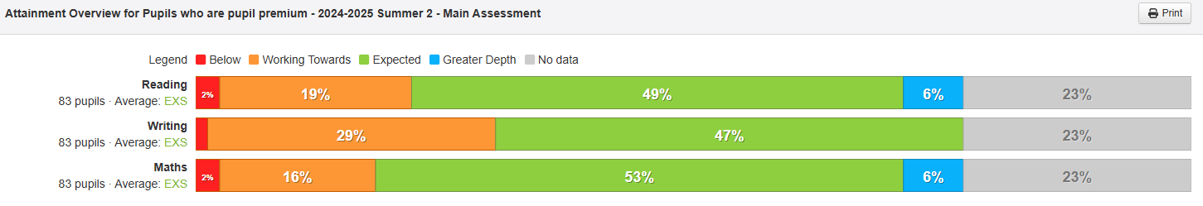

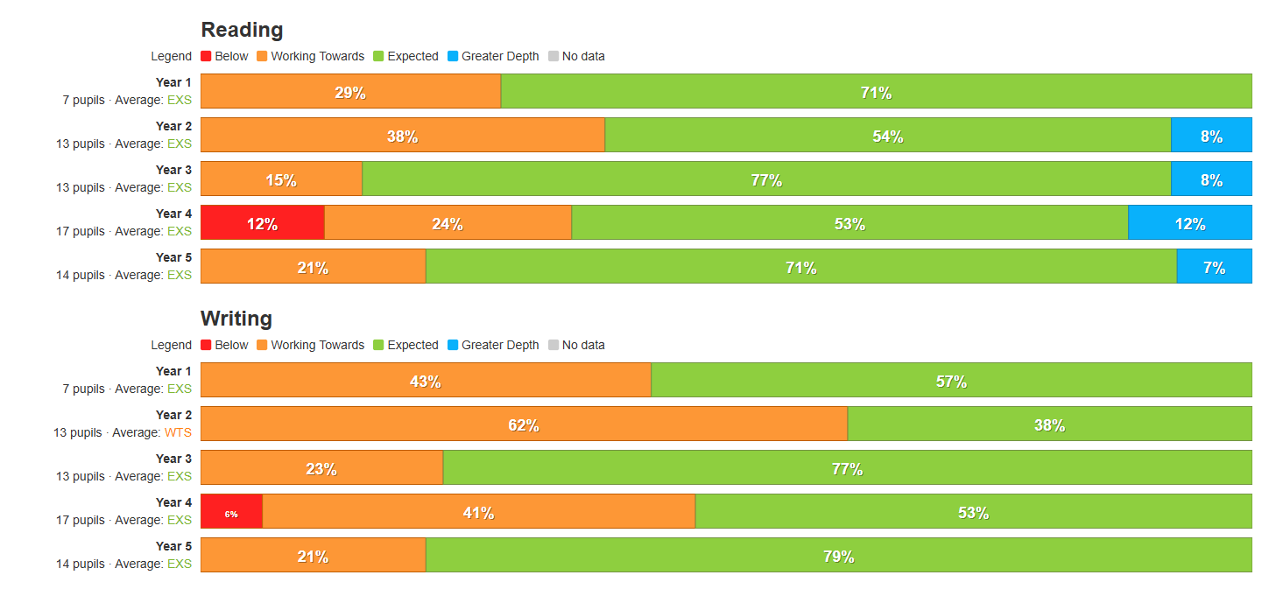

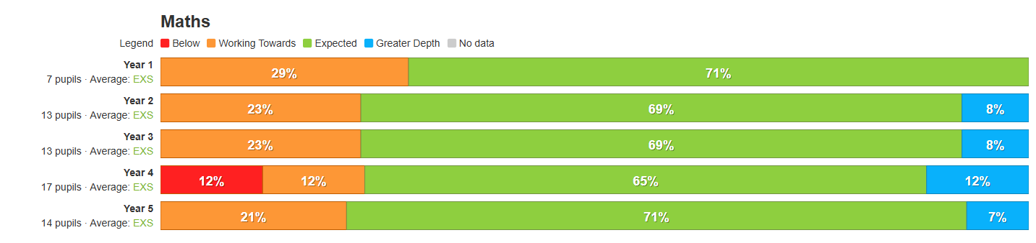

**Main Findings**

|  |  |  |  |  |  |
| --- | --- | --- | --- | --- | --- |
| **Intended outcome** | **Success criteria** | **21/22** | **22/23** | **23/24** | **24/25** |
| The **ACE curriculum** is ensuring QFT is making a difference for our disadvantaged pupils and progress measures show the gap between disadvantaged and others is closing | As a result of careful and focused monitoring our pupils are becoming successful learners (see ACE SL outcomes) |  |  |  |  |
| Journals reflect progress made in all three areas- metacognition, character education and academic excellence (see individual PP tracker) |  |  |  |  |
| The progress of disadvantaged pupils is at least the same as the progress of non-disadvantaged pupils and no greater than a 10% difference by the end of KS2 for reading |  |  |  |  |
| As a result of strong phonics teaching, disadvantaged pupils make accelerated and sustained progress in their writing. |  |  |  |  |
| **Oracy**  All disadvantaged pupils have improved oracy skills and are increasingly able to communicate effectively | Language link programme demonstrates improved language skills for all. | Not in place |  |  |  |
| Our reading strategy is ensuring that by the time children reach Y6 all children are at least at the expected standard |  |  |  | Getting closer to 100%.  Well above National. |
| Vocabulary is explicitly taught through quality first teaching and is planned for by class teachers in all subjects. All classes regularly using the ‘remote control’ cards’ to ensure retrieval of learnt vocabulary |  |  |  |  |
| Our oracy approach (across the curriculum) is evident in terms of key outcomes for pupils. |  |  |  |  |
| Language link programme demonstrates improved language skills for all pupils taking part in interventions |  |  |  |  |
| **Enrichment opportunities** are providing pupils with the skills and knowledge to become more successful learners | Take up of ASCs is high and pupils are clearly gaining through these experiences |  |  |  |  |
| The school seeks meaningful opportunities to broaden pupils horizons eg visiting authors, musical workshops and innovative subject days at our local Secondary schools. This is raising aspirations for children and providing enriching experiences |  |  |  |  |
| All disadvantaged pupils attend residentials, which are partly funded by the school. Pupils participate in a wider range of sports, team games and develop ACE character traits. |  |  |  |  |
| **High quality care** through SEMH support is ensuring excellent wellbeing and readiness for learning | Pupil outcomes have improved in all areas (academically, socially, emotionally, culturally) as a result of our nurture support and bespoke interventions |  |  |  |  |
| Pastoral support is well matched to individual need. The school has achieved Trauma informed accreditation ensuring all staff understand the importance of highly effective relational awareness and good mental health for all |  |  |  |  |
| Soft data identifies that pupils are developing their ability to understand and regulate their emotions |  |  |  |  |
| **Food and Nutrition**  Pupils and families have opportunities in school to participate in workshops and clubs to improve health through food and nutrition education | All pupils have access to free breakfast on entry to school and this in turn supports attendance and readiness to learn |  |  |  |  |
| Children take part in food technology sessions where they develop their cooking skills. Outcomes are shared with families and healthier eating options are explored and adopted by families. |  |  |  |  |
| All children have access to high quality food throughout the school day, being hungry in school is never an issue. |  |  |  |  |
| **Parent/carer partnerships** are strong and parents are increasingly able to support their children’s well being and learning | Improve attendance of disadvantaged pupils to 95%. |  |  |  | 94% |
| Prioritise parent meetings and workshops for children with insufficient resources. E.g phonics workshops to ensure improved engagement with home learning |  |  |  |  |
| Continue to ensure all parents take part in learning enquiry outcomes where parents have the opportunity to share learning, journals and other engaging outcomes |  |  |  |  |
| **Intended outcome** | **Success criteria** | RAG | RAG | RAG |  |

