Torre C of E Academy Preschool Long Term Planner Year A
Autumn 1 |  |  | Autumn 2 |  | Spring 1 |  |  | Spring 2 |  | Summer 1 |  |  |  |  | Summer 2
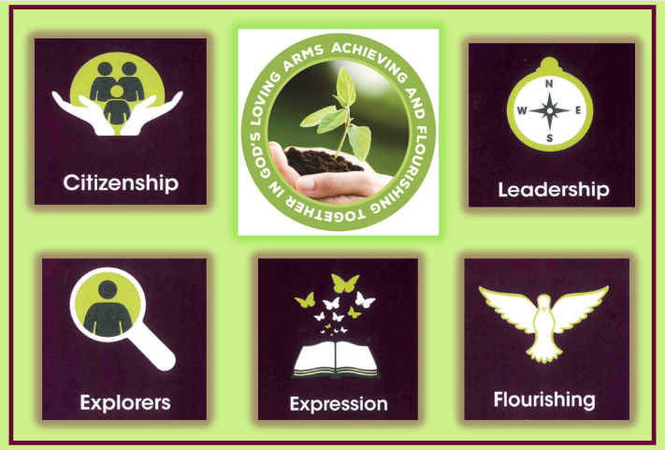  Citizenship-Compassion |  |  | 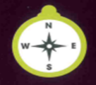  Leadership-Determination/  Integrity |  |   Exploration -Aspiration/Resilience |  |  | 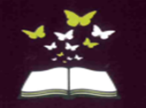  Expression - Confidence/Honesty |  | 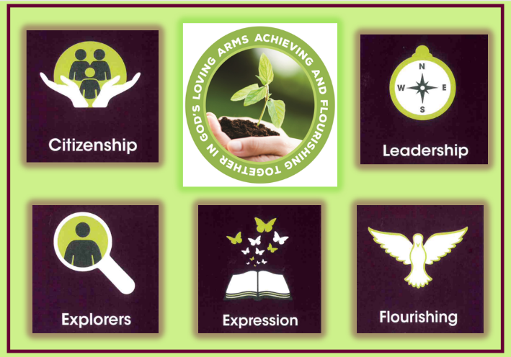  Flourishing - Responsibility/Courage |  |  |  |  | 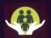  Citizenship-  Drive
Year Group Key Knowledge and Skills
PSED  3 Weeks | UW  Science  3 weeks | UW  Art  3 weeks |  | UW  RWE  3 weeks |  | EAD  DT  3 weeks | UW  Science  3 weeks | UW  Geography  3 weeks | UW  Science  3 weeks | PSED  Geography & DT  3 weeks | EAD  Art  3 weeks |  |  |  | EAD  Music  3 weeks | UW  PSED  3 weeks
I can become more outgoing with unfamiliar people in the safe context of the setting.  I can develop my sense of responsibility and membership of a community.  I can play with one or more children, extending and elaborating play ideas.  I can show more confidence in new social situations. | I can understand the key features of the life cycle of a tree.  I can begin to understand the need to respect and care for the natural environment and all living things.  I can talk about what I see, using a wide vocabulary. | I can explore different materials freely and develop ideas about how to use them and what to make.  I can join different materials and explore different textures.  I can develop my ideas and then decide which materials to use to express them. |  | I can talk about what I see using a wide vocabulary.  I can continue to develop a positive attitude about the differences between people |  | I can explore different materials to develop my own ideas about how to use them and what to make.  I can join different materials.  I can develop my own ideas and decide which materials to use to express them. | I can explore and talk about different forces that I can feel.  I can explore how different things work.  I can use all my senses in hands-on exploration of materials.  I can explore different materials to develop my own ideas about how to use them and what to make. | I am beginning to understand how to respect the natural environment and living things.  I can use my senses in hands-on exploration of natural materials. | I can plant seeds and care for growing plants.  I am beginning to understand how to respect the natural environment and living things.  I can understand the key features of the life cycle of a plant. | I know that there are different countries in the world and talk about the differences they may have experienced or seen in photos.  I can explore how things work. | I can create closed shapes with continuous lines and begin to use lines to represent objects.  I can explore colour and colour mixing.  I can talk about and explore 2 D shapes using informal mathematical language. |  |  |  | I can play instruments with increasing control to express my feelings and ideas.  I know how to create my own song or improvise a song around one I already know.  I know a variety of songs and can sing a whole song.  I know how to sing the melodic shape (moving melody, such as up and down, down and up) of familiar songs. |  | I can develop my sense of responsibility and membership of a community.  I can play with one or more child extending and elaborating play ideas.  I can the print has meaning and for different purposes e.g. invitation
Enquiry Question
What makes a good friend? | What changes can I see in Autumn? | What is in Kipper’s Toybox? |  | How can we use light to celebrate? | How can I join materials together to make a model? |  | What different types of transport are there? | What plants and animals can I find? | What do I need to make a garden for butterflies? | Where does my snack come from? |  | What shapes and colours can I see? |  | What sounds can I hear around me? |  |  | Why is sharing caring?
Outcomes and experiences
To draw a self-portrait. | To make an autumn tree. | To construct a textured picture using different materials. |  | To make a Christingle. | To design and make your own box animal. |  | To make our own big book of transport. | To make a woodland creature. | To make a butterfly garden. | To make banana bread. |  |  | To make a colourful shape painting. |  | To make a sound book. | To plan a party to share together.
Religious and Worldviews Education
Season – Autumn  All about me – families and friends  Special – people and things - treasure boxes  Harvest |  | Festivals of Light  Diwali  Birthdays  Christmas - Christingle  Nativity |  |  | Season – Winter  Tu B’shevat – the birthday of the trees Judaism  Pancake Day  Chinese New Year |  |  | Season - Spring  Lent and Easter |  | Blossom Festival  Creation story  How can we care for our wonderful world?  Growing - link to our garden |  |  |  |  | Season - Summer  Caring for our environment.
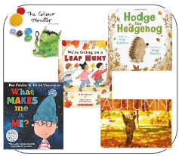 |  | 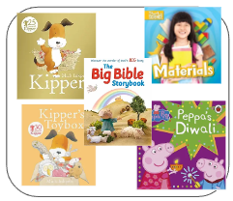 |  |  | 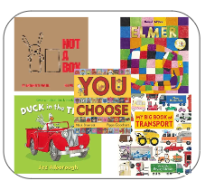 |  |  | 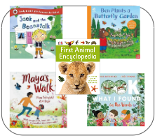 |  | 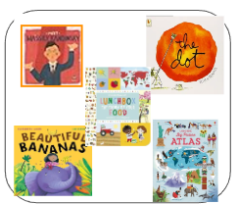 |  |  |  |  | 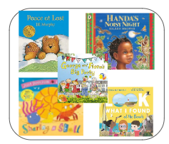
Teaching of other subjects
Religion and Worldviews – a core subject taught weekly Computing - taught weekly PE/Games - taught weekly

Torre C of E Academy Preschool Long Term Planner Year B
Autumn 1 |  |  | Autumn 2 |  | Spring 1 |  |  | Spring 2 |  | Summer 1 |  |  |  |  | Summer 2
Citizenship-Compassion |  |  | Leadership-Determination/  Integrity |  | Exploration -Aspiration/Resilience |  |  | Expression - Confidence/Honesty |  | Flourishing - Responsibility/Courage |  |  |  |  |   Citizenship-Drive
Year Group Key Knowledge and Skills
PSED  3 Weeks | UW  Science  3 weeks | UW  Art  3 weeks |  | UW  RWE  3 weeks |  | UW  Geography and Science  3 weeks | UW  Geography and Music  3 weeks | UW  Science  3 weeks | EAD  DT  3 weeks | PSED  3 weeks | UW  History  3 weeks |  |  |  | EAD  Art  3 weeks | EAD  DT and  Narrative  3 weeks
I can become more outgoing with unfamiliar peopl, in the safe context of the setting.  I can develop my sense of responsibility and membership of a community.  I can play with one or more children, extending and elaborating play ideas.  I can show more confidence in new social situations. | I can understand the key features of the life cycle of a tree.  I can begin to understand the need to respect and care for the natural environment and all living things.  I can talk about what I see, using a wide vocabulary. | I can explorer different materials freely and develop ideas about how to use them and what to make.  I can join different materials and explore different textures.  I can develop my ideas and then decide which materials to use to express them. |  | I can talk about what I see using a wide vocabulary.  I can continue to develop a positive attitude about the differences between people |  | I can use my senses in hands-on exploration of natural materials.  I can explore collections of materials with similar and/or different properties.  I can talk about what I see, using a wide vocabulary.  I can explore how things work.  I can talk about the differences between materials and the changes that I notice. | I can talk about what I see, using a wide vocabulary.  I can use my senses in hands-on exploration of natural environments.  I can take part in simple pretend play, using an object to represent something else even though they are not similar.  I can play with one or more other children,extending and elaborating play ideas. | I can plant seeds and care for growing plants.  I can understand the key features of the life cycle of a plant or animal.  I can begin to understand the need to respect and care for the natural environment and all living things.  I can use all my senses in hands-on exploration of materials.  Talk about what they see, using a wide vocabulary. | I can take part in simple pretend play, using an object to represent something else even though they are not similar.  I can explore different materials freely, to develop my ideas about how to use them and what to make.  I can make healthy choices about food, drink and activity. | I can continue to develop positive attitudes about  the difference between people.  I can show an interest  in different occupations.  I can be more outgoing with unfamiliar people, in the safe context of the setting | I can begin to make sense of my own life story and family’s history.  I can continue to develop positive attitudes about the differences between people. |  |  |  | I can explore colour and colour mixing.  I can draw/ paint with increasing complexity and attention to detail.  I can create closed shapes with continuous lines, and begin to use these shapes to represent objects.  I can draw with increased complexity and detail, such as representing a face with a circle |  | I can take part in simple pretend play, using an object to represent something else even though they are not similar  I can begin to develop complex stories using small world equipment.  I can enjoy listening to longer stories and can remember much of what happens.
Enquiry Question
What makes me a me? | What changes can I see in Autumn? | What is in Kipper’s Toybox? |  | How can we use light to celebrate? | What happens in the season of winter? |  | Where does the family go on an adventure? | How do plants grow? | Why did the caterpillar have a tummy ache? | Who helps us? |  | What has happened before and what is happening now? |  | What colours can I see in nature? |  |  | How did the turnip come out of the ground?
Outcomes and experiences
To draw a self portrait. | To make an autumn tree. | To construct a textured picture using different materials. |  | To make a Christingle. | A frozen science experiment. |  | To go on a bear hunt. | To grow a plant from a seed. | To make a healthy caterpillar snack. | To make people who help us book. |  |  | To talk about now and then photos. |  | To make a spiral picture. | To act our our story with props.
Religious and Worldviews Education
Season – Autumn  All about me – families and friends  Special – people and things - treasure boxes  Harvest |  | Festivals of Light  Diwali  Birthdays  Christmas - Christingle  Nativity |  |  | Season – Winter  Tu B’shevat – the birthday of the trees Judaism  Pancake Day  Chinese New Year |  |  | Season - Spring  Lent and Easter |  | Blossom Festival  Creation story  How can we care for our wonderful world?  Growing - link to our garden |  |  |  |  | Season - Summer  Caring for our environment.
 |  |  |  |  | 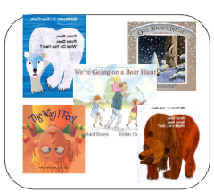 |  |  | 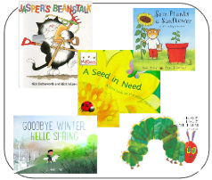 |  | 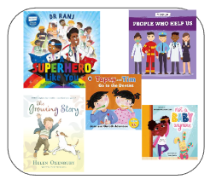 |  |  |  |  | 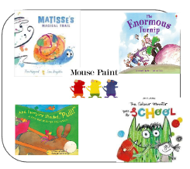
Teaching of other subjects:
Religion and Worldviews – a core subject taught weekly Computing - taught weekly PE/Games - taught weekly

