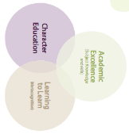
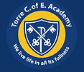

Torre C of E Academy Long Term Planner Year 5/6 Year A 2024-2025
Autumn 1 – Independence |  |  |  | Autumn 2 – Creativity |  |  | Spring 1 - Collaboration |  |  | Spring 2 – Independence |  | Summer 1 – Creativity |  | Summer 2 - Collaboration
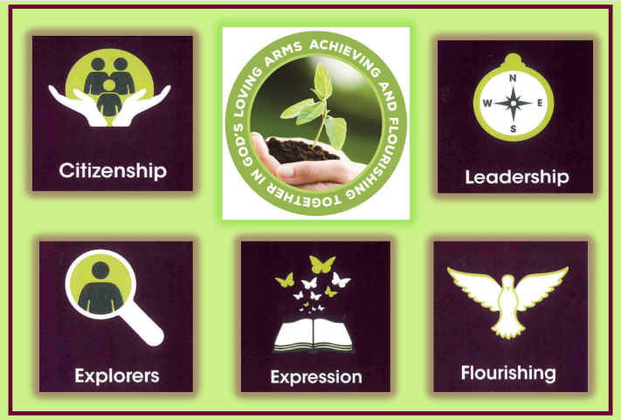  Citizenship-Drive |  |  |  | 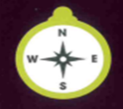  Leadership-Determination |  |  | Exploration -Aspiration |  |  | 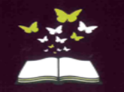  Expression - Confidence |  | 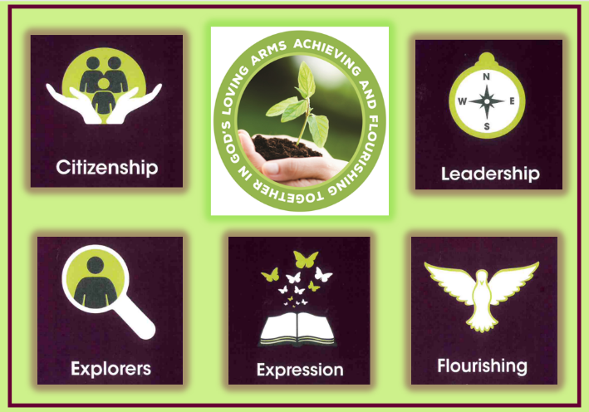  Flourishing - Responsibility |  |   Citizenship-Compassion
Year Group Key Knowledge and Skills
RSHE  (Yr 5)  2 weeks |  | Geography (Yr 5)  3 weeks | D.T  (Yr 5)  1 Week | Science  (Yr 6)  2 weeks | History  (Yr 6)  3 weeks | Narrative  Writing  2 weeks | RSHE  (1 AM Only) | History  (Yr 6)  4 weeks | Science  (Yr 6)  3 weeks | Narrative Writing  3 weeks | Art  (Yr 5)  3 weeks | Geography  (Yr 6)  3 weeks | Science  (Yr 5)  3 weeks | Art  (Yr 5)  2 week | RSE  (Yr ⅚)  1 week | Music  (Yr 5)  3 weeks
Friends and Family  (focus of friends) |  | World Population, Settlement, Migration | Design | Evolution | Local Study  Changes over Time | Wonder | Money Matters | World War 2  DT  Cooking | Electricity and Light | Alma  Music  Annotation - Reading/Creating | Drawing and Painting | Global Challenges | Earth and Space  Forces | Textiles | Safety and SRE | Melody, Rhythm, Chords  Musical annotation: reading and creating
Key Enquiry Question
How can we be a school that challenges discrimination and supports others? |  | Why would people across the world risk their lives to settle in the UK? | How can we design and create a machine that helps lift or move heavy objects? | How has science of the past advanced our knowledge of evolution and adaptation? | Why did Victorian holidaymakers flock to Torquay? | How can I write a first-person narrative that develops character? | How do our choices about money affect ourselves, others and the world around us? | How did the lives of evacuees change in WW2?  DT Cooking - carrot cookies | How can I design an investigation to test electricity and light? | How does a writer build suspense?  Music - What emotions can I utilise to create an aural environment for my cosy mystery writing? | How can create different sketches of Torre Abbey to produce a landscape painting? | What can I do to tackle global warming? | What effect do forces have on us, the Earth and our Solar System? | How can I create a Tapestry using a range of mediums? | What are the challenges of keeping ourselves safe online?  Y5 - How do bodies change during puberty?  Y6 - Why is it important to positive healthy relationships? | ?
Writing Genre and Outcome
Create a leaflet teaching others how to challenge discrimination and support others. |  | Newspaper Report on people coming to the UK. | To create a  design-brief | Non-chronological report about Darwin and his discoveries. | I can write a diary entry of a Victorian holidaymaker visiting Torquay. | I can write a first-person narrative to entertain. | Written reflection. | Evacuee Letter | Design and write own science investigation | 3rd person narrative based on the story of Alma. | To produce a landscape painting of Torre Abbey | Persuasive letter | Non-chronological report | To produce a quilt containing the different fabric techniques | Present how to keep ourselves safe online.
Religious and Worldviews Education
GOD (UC)  What does it mean if God is Holy and loving? |  |  |  | INCARNATION (UC)  Was Jesus the Messiah? |  |  | HINDUS  Why do Hindus want to be good? |  |  | SALVATION (UC)  What did Jesus do to save human beings? |  | ANTI-RACIST RWE  What can be done to reduce racism? Can religion help? |  | FAITH  How does faith help people when life gets hard?
Teaching of Other Subjects
Religion and Worldviews – a core subject taught weekly Music- Taught MFL-weekly lessons using the PLN French Programme
PE/Games including swimming in KS2 taught weekly Computing - Taught weekly

Computing
Autumn 2 - Advanced Skills Part 2 | Spring 2 - Programs to Engage | Summer 2 - Websites and Social Media (See Project Evolve)
How do you improve the functionality and quality of online work? | How do games work? | Why is it everyone's responsibility to stay safe online?
To edit and improve a piece of online work. | To create a fully functional coded game. | To provide a poster with how websites ensure we are safe online.
French

Art/DT Link - Upper School - Art and Design TechnologyArt and Design Technology 2024-25
Music Link - yr 5 6 music.
Spelling Coverage - Spelling Coverage

Torre C of E Academy Long Term Planner Year 5/6 Year B 2025-2026
Autumn 1 – Independence |  |  | Autumn 2 – Creativity |  |  | Spring 1 -Collaboration |  | Spring 2 -Independence |  | Summer 1 – Creativity |  | Summer 2 - Collaboration
Citizenship - Compassion |  |  | Leadership - Integrity |  |  |   Exploration -Resilience |  | Expression - Honesty |  | Flourishing - Courage |  | Citizenship - Drive
Year Group Key Knowledge and Skills
RSHE  (Yr 6)  2 weeks | Geography  (Yr 6)  3 weeks | DT  (Yr 6)  1 week | Science  (Yr 5)  3 weeks | Art  (Yr 6)  2 weeks | Music  (Yr 6)  2 weeks | History  (Yr 5)  4 weeks | Narrative Writing  2 weeks | Science  (Yr5)  (3 weeks) | Narrative Writing  3 weeks | Geography  (Yr 5)  3 weeks | Science  (Yr 6)  3 weeks | DT  (Yr 6)  2 weeks | RSE  (Yr 6)  1 week | History  (Yr 5)  4 weeks
Friends and Family  (focus on family) | World Resources and Trade  Y5 Heatree week - Music  Rehearse, perform and appraise | Make a meal for others | States of Matter | Study (Choice of sculpture, textiles or printing) | Controlling performances and combining devices and effect | Greeks | Partly Cloudy | Living Things | Skellig | Continental  Challenges | Animals including Humans | Making | Safety and SRE | Early Civil Non- European (Mayans)  Art  Drawing and Painting  (Y6)
Key Enquiry Question
What makes a healthy and supportive relationship? | How is a country's wealth determined by its access to natural resources and free trade? | How can I make a healthy jacket potato suitable to sell in our cafe? | Why don’t all materials behave the same? | How can I use the natural beach environment to produce textured clay work? | How does manipulating various elements in music influence the audience’s emotions? | How was life different for Spartan and Athenian children? | How can I paint a picture in the reader’s mind? | How does the life cycle of a human differ from other living things? | How important is language to create imagery in fictional writing? | How does the geography of Bangladesh contribute to its vulnerability? | How can we ensure that our heart stays healthy? | How can I create an electric game for the summer fayre? | How can we develop responsible digital citizenship to safeguard our privacy and online identity?  Y5 - How do bodies change during puberty?  Y6 - Why is it important to positive healthy relationships? | How can I demonstrate my understanding of Mayan life and culture through art?
Writing Genre and Outcome
Create a mind map to show our learning | To write a non-chronological report on the different elements of global trade. | To produce a healthy meal for our school cafe | Write an experiment to demonstrate how materials behave. | To create a sea themed tile and coil pot | Create a section of music using both devices/programme and live voice | Balanced Argument to answer that Enquiry Question | To write a setting description of Partly Cloudy | Persuasion or explanation | A descriptive retelling of an event in Skellig | To write a newspaper report | To write a leaflet | To design and make a game for the summer fayre | Persuasive leaflet to encourage year 3 and 4 to protect their online identity. | Create a Mayan inspired mural in the style of Dan Fenelon
Religious and Worldviews Education
MUSLIMS  What does it mean to be a Muslim in Britain today? |  |  | JEWS  Why is the Torah so important to Jewish people? |  |  | CREATION/  FALL (UC)  Creation and Science: Conflicting or complementary? |  | HUMANISM  What matters to most Humanists and Christians? |  | GOSPEL (UC)  What would Jesus do? |  | KINGDOM OF GOD (UC)  What kind of king is Jesus?
Teaching of Other Subjects
Religion and Worldviews – a core subject taught weekly Music- MFL-weekly lessons using the PLN French Programme
PE/Games including swimming in KS2 taught weekly Computing - Taught weekly

