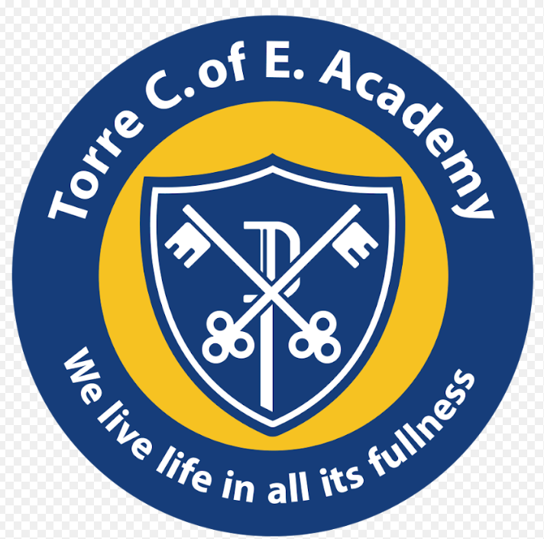
Torre C of E Academy Assessment Policy

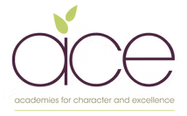

Our assessment and reporting system includes both formative (Assessment to Improve) and summative assessments (Assessment to Prove):

Formative examples:
- Ongoing assessment by the class teacher throughout each lesson, through questioning, observation and dialogue.
- Children knowing what they are being asked to learn and more importantly, why.
- Pupils are encouraged to self-assess against learning questions at appropriate stages during a learning experience.
- Children will dot the learning question in green if they feel they have achieved it, orange if they feel they have partially achieved it and pink if they feel they haven’t achieved it.
- Live marking and feedback is given to the children where appropriate.

Summative examples:
- Phonics Screening Check in Year 1. In addition to this we use the RWI assessments.
- Multiplication check in Year 4.
- Statutory government standardised tests in Years 2 and 6. Year 2 is optional but as school we choose to use these to support teacher judgements.
- An age standardised test in the Summer term in maths, SPAG and reading (PIRA, GAPS and PUMA). These are used in Year 3,4 and 5.

The above will all be used to make a judgement about whether a child is predicted to be at age-related expectations at the end of the Summer Term.

Teachers complete a year group profile at the end of each term and this, in addition to all of the above will feed into our termly Pupil Progress Meetings, where the attainment and progress of all pupils is discussed. Teachers will predict whether a child will meet age-related expectations by the end of the Summer Term. Any child who is flagged up as ‘stuck’ or ‘falling behind’ will be discussed in depth at the Pupil Progress Meetings. Barriers for each child will be identified and appropriate support and interventions will be agreed and placed onto the Pupils Falling Behind Grid for careful monitoring.

All pupils eligible for pupil premium funding will be discussed at the Pupil Progress Meetings to ensure that there is a sharp focus on where these sometimes hard to reach children are achieving and how their attainment and progress can be raised.

Tracking progress over time
Teachers will enter predictions for the end of the year on INSIGHT each term in maths, reading, writing, SPAG and RWE. At the end of each term the percentage of children in each year group who are predicted to be at ARE by the end of the Summer term will be recorded on a year group profile.

At the end of the year pupils actual attainment will be recorded on INSIGHT The children will be recorded as:
- B (working below the expected year group)
- WTS (working below the expected level in the correct year group)
- EXS (working at the expected level in the correct year group)
- GDS (working at greater depth within the correct year group)

Any children who are at B or WTS will be highlighted on the Pupil Progress Meeting documents for their year group.

Depth of Learning in a Mastery Curriculum
Pupils are expected to fully ‘master’ the curriculum for their age-group, in order to be deemed as working at age related expectation for their year group. Over time, a child’s ability to reason and apply their learning should improve.

More-able children
Rather than moving onto the next year’s curriculum, able pupils will work on ‘mastering’ their knowledge through the application of skills in different contexts – they will be deepening their learning. The depth and application of a child’s learning is an important marker of their achievement and progress.

Early Years - Preschool & Reception (and see Appendix)
Children in Preschool and Reception will continue to be assessed against the Prime and Specific areas of Learning in the EYFS profile.

Assessments will be based on observation of daily activities and events both through child initiated play and through adult directed time. At the end of Reception for each Early Learning Goal, teachers will use a holistic, best fit judgement as to whether a child is meeting the level of development expected at the end of the Reception year:
- Emerging, not yet reached the expected level of development
- Expected

Children’s progress is evaluated on their learning outcomes in relation to 7 Early Learning Goals. The reformed Early Learning Goals are now statutory for all early years settings. The 7 Early Learning Goals are:
- Communication and Language
- Physical Development
- Personal, Social and Emotional Development (PSED)
- Literacy
- Maths
- Understanding the World
- Expressive Arts and Design
The progress of Preschool and Reception cohorts are tracked half termly in all areas as a whole group.

In planning and guiding what children learn, practitioners reflect on the different rates at which children are developing and adjust their practice appropriately.
Three characteristics of effective teaching and learning are:
• playing and exploring - children investigate and experience things, and ‘have a go’
• active learning - children concentrate and keep on trying if they encounter difficulties, and enjoy achievements
• creating and thinking critically - children have and develop their own ideas, make links between ideas, and develop strategies for doing things

National Reception Baseline
In September 2021 a national statutory baseline assessment was introduced for all reception children to complete in the first six weeks of school. These assessments will assess language, communication, literacy and mathematics. These provide a numerical score which will not be shared with parents or schools until the child is at the end of year 6. It will then be used as a progress measure. Reception teachers will be provided with some narrative statements explaining how their pupils performed in the assessment which can be used to inform teaching within the first term.

Assessment follows the following cycle:

Plan – Plan learning effectively
Assess – Making judgements in the classroom
Record – Record judgements and set targets
Analyse – Identify patterns and trends

The DfE and Ofsted will measure progress formally at the end of KS1 and the end of KS2 against the performance descriptors. This will be reported as a scaled score. This will also be used as a progress measure for children from the end of KS1 to the end of KS2.

Examples:
A child with a scaled score of 100 at the end of KS1 will be expected to achieve a scaled score of 100 at the end of KS2 to have made expected progress.
A child with a scaled score of 105 at the end of KS1 will be expected to achieve a scaled score of 105 at the end of KS2 to have made expected progress.
A child with a scaled score of 97 at the end of KS1 will be expected to achieve a scaled score of 97 at the end of KS2 to have made expected progress.

Standardisation and Moderation

It is essential that regular standardisation and moderation opportunities are planned in. At Torre, reading, writing and maths are moderated in school and cross-school at least annually.

Maths: At the beginning of a block of work the teacher will assess the starting point through an elicitation task or activity. Elicitation tasks will vary between blocks and between year groups. At the end of a block an assessment task will be given. If this is written task, these will be completed on blue paper so they are easily identifiable in the pupils’ books. At the end of year, children will be given the appropriate PUMA test to obtain a standardised score in year 3, 4 and 5. Year 2 and year 6 will use previous SATS papers to gain an standardised score. Teachers will analyse tests in order to identify both individual gaps in learning but also possible implications for the way something is taught.
Reading: In Early Years, Reception and Key Stage 1 children’s phonic knowledge is assessed regularly on a 1:1 basis. Children are heard read during the Read, Write, Inc phonics sessions. Children are assessed half termly using the RWI assessments to track progress and identify any gaps. When children have graduated phonics in Key Stage 1, they have additional whole class guided reading sessions where children are observed for assessment purposes.
Writing: Teachers use a range of independently completed pieces of writing from across the curriculum to make their termly predictions and end of year judgements in writing. A sample of these judgements are moderated both internally and externally. Teachers will use Evidence Gathering Grids to support making their judgements.
Religious and World Views Education (RWE): In RWE, there is an end of enquiry evaluation (EEE) for each unit of work. It outlines the expected standards to be met for a child who is judged at being secure. The children are judged against disciplinary knowledge and substantive knowledge as either WTS, ARE or GD. Teachers will use this EEE as guidance when submitting their judgments for each child. At the end of each term, teachers will input a judgement for each child on INSIGHT.

Science and other foundation subjects: In Key Stage 1 and 2 EEEs are used for each learning experience. It outlines the expected standards to be met for a child who is judged at being secure. The children are judged against disciplinary knowledge and substantive knowledge as either WTS, ARE or GD. Next steps for key children will be identified and will inform future planning and intervention. Teachers will also use this EEE as guidance when submitting their judgments for each child. At the end of year, teachers will input a judgement for each child on INSIGHT. Teachers will make judgements based on observations, work in books and any other useful assessments.

Monitoring the quality of assessment

The governing body plays a key role in the implementation of the assessment policy. During class visits and monitoring visits, governors talk to pupils and ask about their learning and what they have to do to improve. Comments are shared with the senior leadership team and then fed back to individual teachers.

Published data is scrutinised by the governing body and the Chair of Governors challenges the Head Teacher at the end of term regarding current performance of each class of pupils and any issues. Issues are high-lighted and then monitored.

Teachers will be involved in in-school and cross school moderation to ensure the consistency of judgements.

The future of assessment
Our Headteacher is leading an assessment project group on behalf of our trust (Academies for Character and Excellence). The group has been carrying out school based assessment research as well as collaborating with the national group ‘Rethinking Assessment’. They are currently working on a new assessment approach that will develop a holistic learner profile for all children, not only assessing academic progress but character development and metacognitive skills. Read their published blog for further insight- https://rethinkingassessment.com/rethinking-blogs/resisting-the-tyranny-of-the-urgent/ .

Assessment to improve
(Marking and Feedback) Guidance

Assessing to improve is the process of challenging and deepening thinking and clarifying understanding in order to make improvements. This can take a range of forms including; written feedback, verbal feedback, peer or self assessment etc. This collaborative process enables children to grow and achieve more than they could alone.
Our Key Principles
Feedback is best when…
- It moves the learning forward, addressing misconceptions.
- It is live, purposeful and meaningful to the child.
- Children are able to engage with it in order to make progress.
- It engages children to reflect upon their learning.
- Space, time and priority is given to allow for this practice.
- It can be reflected upon and revisited to support recall for long term learning.
- It allows the teacher to judge the effectiveness of pedagogy and informs next steps.


EYFS | Verbal feedback in the moment  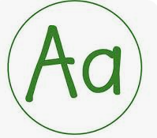  Writing  Stampers used as feedback and a target for improvement  Pink will highlight next steps  Green will underline success
KS1 | Learning focus is highlighted to show level of achievement  Green LF met  Orange LF partially met  Pink LF not met  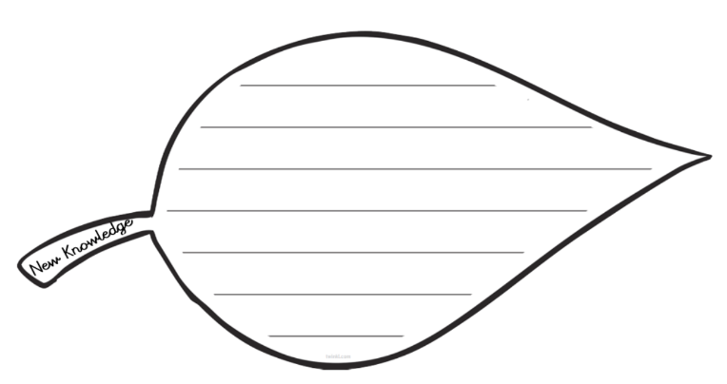Children add new knowledge or edit their learning using the ‘New Knowledge Leaf’  Teacher comments  Teachers may write comments that will help a child to reflect and improve. These comments are written in PINK. Teachers are not expected to write a comment unless it is going to have a direct impact on a child’s progress.  Maths - Year 2 onwards.  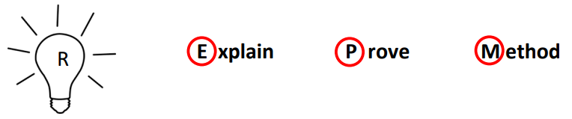  Teachers will use the above codes to ask children to reflect and respond further. The children can write the E P M themselves as a form of self reflection.  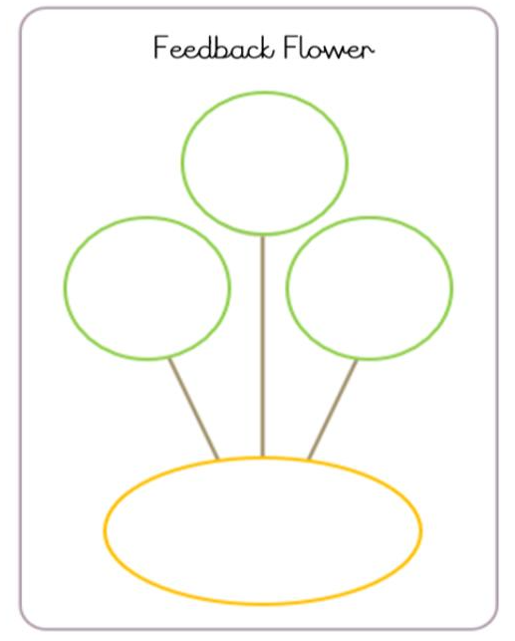  The feedback flower is a form of peer assessment  and teacher target setting will also be given below.  Children are expected to revisit the target circle  before starting their next piece of work.  Changes and edits that need to be made will either be verbally highlighted with a child and response to this will be seen with use of green and pink highlighters. These will be used to underline strengths and areas for development that must be responded to e.g. through edits or a planned workshop/intervention.
KS2 | Learning focus is highlighted to show level of achievement  Green LF met  Orange LF partially met  Pink LF not met    Children use a purple pen to make edits, respond to their teacher or demonstrate understanding.  Teacher comments  Teachers may write comments that will help a child to reflect and improve. These comments are written in PINK. Teachers are not expected to write a comment unless it is going to have a direct impact on a child’s progress.  Maths  Teachers will use the above codes to ask children to reflect and respond further. The children can write the E P M themselves as a form of self reflection.  The feedback flower is a form of peer assessment  and teacher target setting will also  be given below.  Children are expected to revisit the target circle  before starting their next piece of work.    Thinking Column  KS2 children use a thinking column whilst journaling. This is a space for reflection and note taking both independently and prompted by an adult in order support further growth and metacognition.  Changes and edits that need to be made will either be verbally highlighted with a child and response to this will be seen in purple pen or with the use of green and pink highlighting. Strengths and areas for development identified must be responded to e.g. through edits or a planned workshop/intervention.
APPENDIX
Baseline assessment (Nursery) EA framework - Nov 2020
When children start in our nursery provision we use the check points described in the Development Matters Framework (2020) whilst observing and playing with the children in the environment. These give the preschool team an indication of the needs across the preschool and help to shape the provision.

Can the child shift from one task to another if you get their attention. Using the child’s name can help. “Jason, can you stop now? We’re tidying up”.
Can the child use around 300 words? These include descriptive language. They include words for time (for example: now, later), space (for example, over there) and function (for example, they can tell you a sponge is for washing)
Is the child linking up to five words together?
Is the child using pronouns (me, him, she), and using plurals and prepositions (in, on, under) – these may not always be used correctly to start with.
Can the child follow instructions with three key words like: “can you wash dolly’s face?”
Can the child show that they understand action words by pointing to the right picture in a book. For example: “who’s jumping?”
Can the child shift from one task to another if you fully obtain their attention, for example, by using their name?
Does the child start to enjoy the company of other children and want to play with them?
Can the child sometimes manage to share or take turns with others, with adult guidance and understanding ‘yours’ and ‘mine’?
Can the child settle to some activities for a while?
Can the child climb confidently, catch a large ball and pedal a tricycle?

Baseline assessment (Reception) EA framework - Nov 2020
In the first few weeks of reception the adults spend time getting to know the children through meaningful interactions and by observing them interacting with and in the environment. We have decided the following information will be usual to be gathered to give us a starting point for all of the children and inform next steps.
Communication and Language
- Noticing how the child communicates. Are they saying mainly one or two-word statements, or speaking in sentences? Can you generally understand what they say? What languages do they speak? Do they appear to understand what you say to them? A few telling examples will cover this. Note down the exact words they spoke whilst they played with you. Find out more from their parents.
Personal, social and emotional development
- Observing the child’s confidence. Do they get stuck in and start to play from day one? Are they sociable and quick to make friends? Or do they struggle to separate from their parent? Again, a few telling examples will cover all you need. What happened the first time when their parent left? Is there an example of them playing with another child? What do parents say?
Physical development
- Noticing the child’s physical competence and also their self-care. This will include how they manage hand-washing and toileting, snack and mealtimes. How do they manage steps and equipment for large motor skill development like slides? How do they manage equipment for small motor skill development like construction kits or colouring pencils? Once again, teachers and early years educators will quickly get a sense of the child’s development in this area, which can usefully be supplemented by parents.
Specific areas of learning assessment required for starting points
- Letter sound knowledge ( to inform RWI)
- Number recognition, shape recognition and counting skills

